**To:** The Chief Constable, [Police station]

For convenience in sharing and working with the the links of this document it can be downloaded from:   
<https://bluetoothfreedom.com/index.php/documents/>

**Regarding:** Illegal Bluetooth devices

Dear Chief Constable,

With the following letter I would like to inform you about the existence of a significant number of illegal Bluetooth devices in almost all settlements in the country. Such types of illegal devices are being detected in every police station in the UK as well.

These Bluetooth devices can be detected with the following mobile applications:  
  
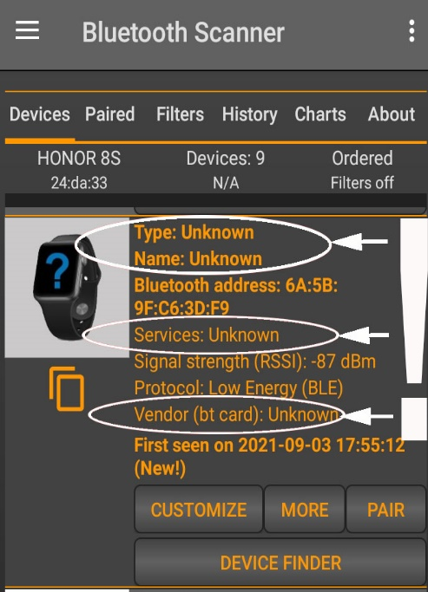**Android:** **“**[**Bluetooth Scanner - Bluetooth finder - pairing**](https://play.google.com/store/apps/details?id=com.pzolee.bluetoothscanner) **”** byZoltan Pallagi (recommended)**,** “[Microchip Bluetooth Data](https://play.google.com/store/apps/details?id=com.microchip.bluetooth.data)”, “[Find My Bluetooth Device](https://play.google.com/store/apps/details?id=com.findmybluetooth.headset.headphones.devices)”, “[Free EMF Detector, EMF Meter – ElectroSmart](https://play.google.com/store/apps/details?id=fr.inria.es.electrosmart)”, a.o.  
**iPhone:** ”[**Bluetooth BLE device**](https://apps.apple.com/us/app/bluetooth-ble-device-finder/id1465245157)**”** (recommended), “[BLE Scanner 4.0](https://apps.apple.com/es/app/ble-scanner-4-0/id1221763603)”, “[Find My Bluetooth Device Pro](https://apps.apple.com/py/app/find-my-bluetooth-device-pro/id1567509235)”, “[Find My Bluetooth Device](https://apps.apple.com/py/app/find-my-bluetooth-device-pro/id1468725639)” or “[Scanner Bluetooth](https://apps.apple.com/es/app/scanner-bluetooth/id1434984259) a.o.

When discovered with the app “[Bluetooth Scanner - Bluetooth Finder - Pairing](https://play.google.com/store/apps/details?id=com.pzolee.bluetoothscanner)” (Android), the Bluetooth devices come up as:  
**Type: UNKNOWN, Name: UNKNOWN, Services: UNKNOWN, and Vendor (bt card): UNKNOWN**.   
Only the MAC address is being displayed without any information about the device. The additional verification of these Bluetooth devices through specialised websites such as <https://maclookup.app/> also confirms that no information is available about them. Here we’ve got the same situation as in the case when one enters a car registration number in a vehicle check website and sees that no information is available on the type of vehicle, year of manufacture, owner, MOT, insurance, tax, etc. In other words, these Bluetooth devices are just as illegal and criminal as vehicles with fake licence plates. A quick check of the device’s major class code (seen in the MORE menu of the app – see attachment 1) confirms that these devices fall in the category “laboratory probes”, i.e. somebody has produced them just like in a lab, but never registered them officially, as the international procedure requires.

The presence of such type illegal telecommunication activity, including in your premises, requires active measures for **identification of: the devices**, **their purpose, who installed them**, **what are the motives** of the people who installed them, **what are the consequences** and **what are the measures,** necessary to remove these illegal Bluetooth devices and prevent the possibility of this crime happening again.

Here, if you allow me, I would like to help you with the answer to all the questions above.

1. **WHAT ARE THESE BLUETOOTH DEVICES?**These are the Bluetooth chips of the vaccinated. Unfortunately, vaccinated people are chipped without their knowledge and consent. The exact procedure for identifying the presence of a Bluetooth chip in a vaccinated individual by using a mobile phone is explained in ATTACHMENT 1 (video instruction: [How to find the Bluetooth chip in vaccinated people](https://www.bitchute.com/video/OC7HW6FXTsPU/)). This check takes just about 10-20 minutes. You can also see the video and document of the study conducted by a French group of scientists on detecting Bluetooth signals from the human bodies with 37 volunteers. Website with video: <https://operationxb.citizen-light.com> . Document: <https://tiny.cc/vaxchip_scires> . The Spanish doctor, Dr. Luis Benito, reports that he found the signal in 96 of 112 tested vaccinated individuals <https://dailyexpose.uk/2022/01/29/doctor-detects-mac-addresses-in-covid-vaccinated-individuals-with-bluetooth-applications> ). The best summary of over 20,000 hours of research on this topic from teams around the world can be seen here: [la quinta columna confirms what’s in the vaccine](https://www.bitchute.com/video/BQYZU2epFxlR/) as in [this material with deep technical details](https://www.bitchute.com/video/4XmDOAeNMNBS/) .
2. **PURPOSE OF THE BLUETOOTH DEVICES**As explained in incredible details and clarity in the video on Bitchute.com: [**LA QUINTA COLUMNA CONFIRMS WHAT’S IN THE VACCINE**](https://www.bitchute.com/video/BQYZU2epFxlR/)the purpose of these Bluetooth devices is to connect the human nervous system with the internet of things and transform the vaccinated into bio-robots without their own will where they will be subjected to complete biological, emotional and mind control from a distance through the telecommunication systems and AI.
3. **WHO INSTALLED THESE DEVICES?**While it is clear that the vaccine producers have inserted the graphene oxide nano-technology in the vaccines there are other people as well who are involved in this initiative. These are the leaders of the so called New World Order who openly declare their plans of chipping the population with the proclaimed intend to optimise the health system in society and introduce the new 4th human revolution, which will be revolution of how we see the world, how we do things, how we transform ourselves and a period where we will be able to produce human beings and human brains and have an evolution by design rather than a free will of the soul.
4. **WHAT IS THE MOTIVATION OF THE PEOPLE WHO INSTALLED THESE BLUETOOTH DEVICES?**The motivations can be understood best from the video explaining in details the whole operational system installed in the bodies of the vaccinated, [la quinta columna confirms what’s in the vaccine](https://www.bitchute.com/video/BQYZU2epFxlR/)**,** but also directly from Yuval Noah Harari, one of the main consultants to Klaus Schwab, the leader of the World Economic Forum, which is a key organisation through which the plans for The New World Order are being developed and implemented. The motivation is to put into a **COMPLETE ELECTRONIC PRISON** all the future generations on the planet and divide the society into masters who run this electronic Matrix and slaves who being bio-robots are completely incapable of having their own will as everything from their biology, through their emotions and mind is being programed through computer algorithms managed by AI and serving the needs of the owners of the private corporations that are secretly introducing these technologies in the society under the disguise of antiviral vaccines and other means. This organisation openly talks about the future of [AI and the Internet of Bodies](https://www.bitchute.com/video/loAb3uDgTFj8/) without mentioning that they’ve implemented this plan without the knowledge and consent of the people.   
   The catastrophic amount of deaths and injuries caused by the vaccines due to the high toxicity of the graphene oxide and the negative side effects from the spike proteins and whole bunch of other non-disclosed materials in the vials like chromium, nickel, sulphur, chloride, nitrogen, bismuth, titanium, vanadium, iron, copper, silicon and aluminium, the carcinogenic and genotoxic Poly-ethylene glycol (PEG) and ethylene alcohol and also parasites inevitably lead to the conclusion that there’s an additional motivation to the attack on humanity disguised as health measures against COVID and THIS MOTIVATION IS **DEPOPULATION**. Those who closely follow the writings and speeches of the leaders who have embraced The New World Order have found many quotes and evidences that point to the intend of this group to bring the world population down to a manageable limit of below 1 billion people.

**HUMANS ARE NOW HACKABLE ANIMALS**  
Yuval Noah Harari from the World Economic Forum : “In the past many governments wanted to do it, but no one understood biology well enough and no one had enough computing power and data to hack millions of people. Neither the Gestapo, nor the KGB could do it. **But soon at least some corporations and governments will be able to systematically hack all the people**. We humans will get used to the idea that we are no longer mysterious souls. **We are now hackable animals**…Data might enable elites to do something even more radical than just field physical dictatorships. By hacking organisms elites may gain the power to reengineer the future of life itself… Science is replacing evolution by natural selection with evolution by intelligent design, not by intelligent design of some god above the clouds, but our intelligent design”.  
[Yuval Noah Harari explain the great reset / transhumanism agenda](https://www.bitchute.com/video/Et7fpwZeviMU/);   
[Free will is over](https://www.bitchute.com/video/Zwc2s4US4PdE/);  
[Covid Is Critical For People To Agree To Surveillance Under The Skin](https://www.bitchute.com/video/lbLsb9oPQ5pP/);  
["Meaningless, Worthless People](https://www.bitchute.com/video/Yn2fjPLqSpWA/)"

1. **WHAT ARE THE CONSEQUENCES?**
   * **[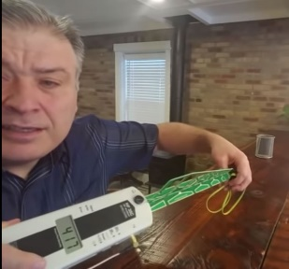](https://www.radiationhealthrisks.com/bluetooth-technology-radiation/)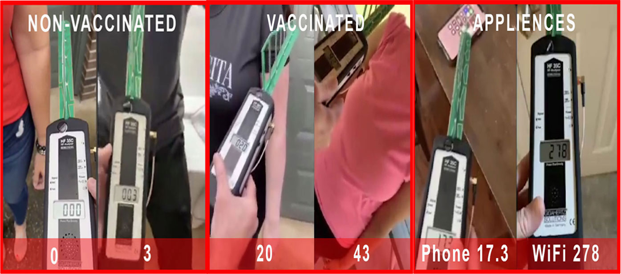CONSTANT 24/7 BLUETOOTH RADIATION (2.4 GHZ) EMISSIONS FROM THE BODY**Bluetooth devices emit RF radiation. There have been hundreds of peer reviewed studies on RF radiation and its harmful effects since 1960. The article [Is Bluetooth Radiation Dangerous?](https://www.radiationhealthrisks.com/bluetooth-technology-radiation/) from the website <https://www.radiationhealthrisks.com> throws light on the real and unsuspected dangers of the Bluetooth type of RF radiation. Youtube video with a demo: [How Much Radiation Do Cellphones & Bluetooth Earbuds Emit?](https://youtu.be/HB_OYdoFwf8)In the [BREAKING: HIGH FREQUENCY VAXED PEOPLE](https://www.bitchute.com/video/Yq7tpAMs8z6p/) video on Bitchute there are real life measurements done with professional equipment for evaluating the RF radiation of vaccinated people. While the device measured 0 to 3 with non-vaccinated the indications with vaccinated are 20 to 43. For comparison, the mobile phone on the video gave a measure of 17.3 and the WiFi router 278. The **HARMFUL RF RADIATION** emitted from the bodies of the vaccinated people **IS REAL**.   
       
     RF radiation is proven to cause **cancer, DNA damage (especially in infants and fetuses), crib death, male infertility, autism, heart problems, heart palpitations, heart arrhythmias, leg cramps, vertigo (balance problems), sleeping disorders, headaches, ringing in the ears, eye problems** a.o.
   * 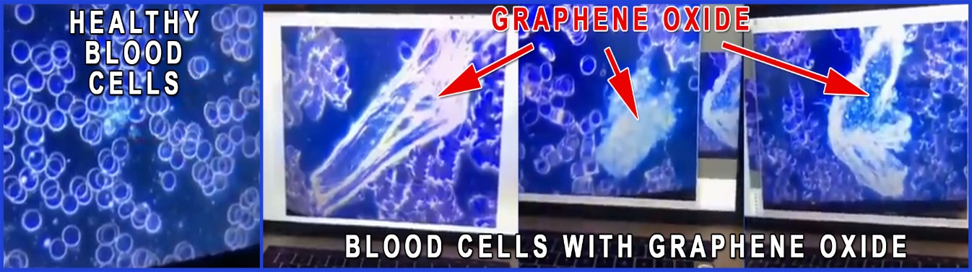**GRAPHENE OXIDE, THE BLUETOOTH NANO CHIP BUILDING MATERIAL, IS HIGHLY TOXIC**The independent laboratory tests show that graphene oxide is the material with which the Bluetooth nano devices inside the vaccinated are made. Unfortunately, this material is highly toxic.  
       
     The effects of the graphene oxide on blood health can be seen and understood by everyone when looked under a microscope. Healthy blood cells have nice round shapes, they have large space between them and move freely around. The blood cells contaminated with graphene oxide are deformed (sign of bad health of the cell), they are coagulated (stacked together in groups) and their movement is strongly impaired. Naturally, an organism with such a kind of blood disorder will be subjected to low oxygen levels and all abnormalities coming from the poor condition of the blood.   
       
     Graphene oxide causes anything from **headache and smell loss to serious nervous disorders, cancer, DNA damage, leukaemia, infertility, pulmonary fibrosis, mitochondrial damage, stem cells damage, gut damage, testis damage, blood clots leading to heart attacks and others**. Perhaps the largest body of studies done on the toxicity of graphene oxide can be found on the page of the Spanish research website La Quinta Columna: <https://www.laquintacolumna.net/> . Here’s a list of about 60 publications done on the toxicity of graphene oxide in the human body:  
     [REPORTS AND SCIENTIFIC PUBLICATIONS ON THE TOXICITY OF GRAPHENE OXIDE TO LIVING ORGANISMS AND TO HUMANS IN PARTICULAR](https://www.dropbox.com/s/xcfp8arvikjgi21/2-%20GRAPHENE%20OXIDE%20TOXICITY%20REPORT.pdf?dl=0)
   * **DANGEROUS COMBINATION BETWEEN 5G AND GRAPHENE OXIDE INSIDE THE VACCINATED**5G all by itself is already a life threatening influence in our environment (a must watch video on 5G: [**5G APOCALYPSE – THE EXTINCTION EVENT**](https://youtu.be/C2Z_cSL24eo) by Sacha Stone). When 5G activates the graphene oxide inside the bodies of the vaccinated it can lead to unpredictable consequences. On one hand the level of radiation of the vaccinated will be higher and on the other graphene oxide can become “alive” and move and take different shapes as seen on many demo videos (see Attachment 5: Massmurder through graphene oxide is possible).
   * [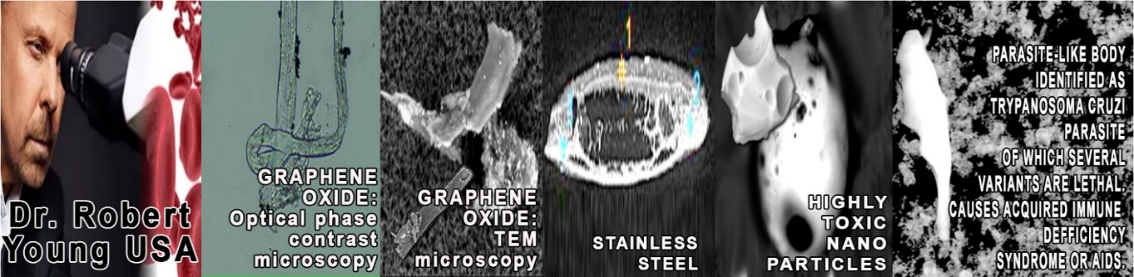](https://www.drrobertyoung.com/post/transmission-electron-microscopy-reveals-graphene-oxide-in-cov-19-vaccines)**ADVERSE EFFECTS FROM OTHER NON-DISCLOSED SUBSTANCES IN THE VACCINES**Official data has shown that there are **more adverse effects from the COVID vaccines compared to all vaccines in the last 30 years taken together**. They are due to the graphene oxide, the toxicity of the spike protein and the impact of all other non-disclosed substances. Shockingly, there were also parasites observed in the vials of Pfizer and Moderna.   
     Dr. Bryan Ardis presented a series of evidence for the presence of synthesised king cobra’s venom in the vaccines ([WATCH THE WATER](https://rumble.com/v10mnew-live-world-premiere-watch-the-water.html)).   
     A most thorough microscopic study using different techniques for spectrum analysis was conducted by the world renowned scientist Dr. Robert Young. He was able to identify not only the graphene oxide, but also parasites and a whole bunch of other non-disclosed materials like chromium, nickel, sulphur, chloride, nitrogen, bismuth, titanium, vanadium, iron, copper, silicon and aluminium. The presence of the carcinogenic and genotoxic **Poly-ethylene glycol (PEG)** and **ethylene alcohol** was also registered. The research document can be found on Dr. Young’s website, <https://www.drrobertyoung.com/post/transmission-electron-microscopy-reveals-graphene-oxide-in-cov-19-vaccines> , or as a video discussion: **Bitchute.com**, [Dr. Robert Young GRAPHENE, ALUMINIUM, STAINLESS STEEL, LNP-GO CAPSIDS, PARASITES FOUND IN 4 VACCINES](https://www.bitchute.com/video/k5JasyhiwEGO/)
   * 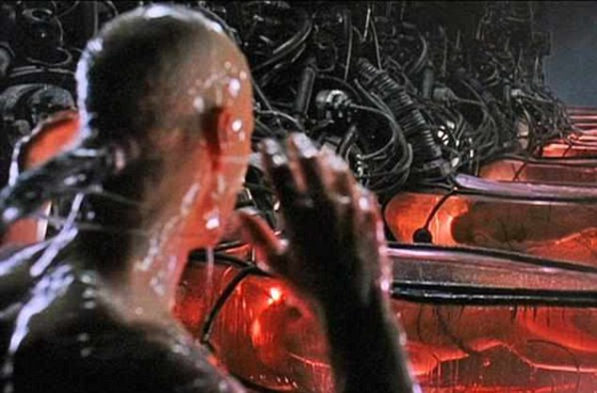**COMPLETE BODY, HEALTH, EMOTION AND MIND CONTROL**By connecting the Bluetooth microchip operating system in the body with the mobile phones, the telecommunications systems and AI all vaccinated individuals are exposed to a complete body, health, emotion and mind control by the private corporations who have installed these operating systems. The vaccinated now are practically bio-robots owned by the corporations. This new type of social development in the world is openly supported by the globalist like Yuval Noah Harari from The World Economic Forum, a close associate to Claus Schwab, who is the mind-master of this organisation ([Yuval Noah Harari explain the great reset / transhumanism agenda](https://www.bitchute.com/video/Et7fpwZeviMU/); [Free will is over](https://www.bitchute.com/video/Zwc2s4US4PdE/) , [Covid Is Critical For People To Agree To Surveillance Under The Skin](https://www.bitchute.com/video/lbLsb9oPQ5pP/), [Yuval Noah Harari Calling the Masses "Meaningless, Worthless People](https://www.bitchute.com/video/Yn2fjPLqSpWA/)" ). Having in mind that these leaders believe in the depopulation agenda where the majority of the world population is “meaningless and worthless” it isn’t hard to guess what the corporations will do with this newly acquired power over the bodies and minds of people. The most probable use of this Bluetooth connection will be to create a series of believes, emotions, biological and social conditions and circumstances that will naturally lead to the extinction of the vast majority of the vaccinated and wouldn’t allow their reproduction to keep down the numbers of these “meaningless and worthless” bio-units on the planet that they believe that they own. Anything from any kind of mood, through any kind of disease and creating events on a larger social level becomes available at their fingertips as a computer game. Now they can commit even mass murder from a distance and get away with it as long as people are completely unaware of this Bluetooth biological operational system (see the section for the mass-murder at a concert in the US: Attachement 5 Мassmurder through graphene oxide is possible).

To sum it all up, the next page provides a visualization of what these illegal Bluetooth devices actually are.

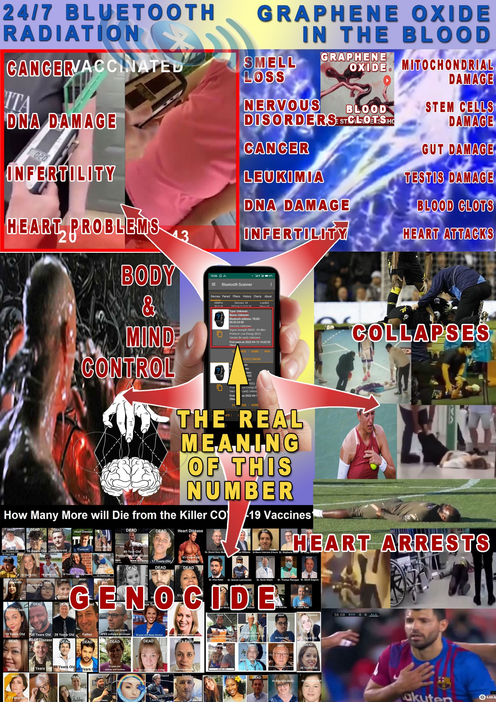

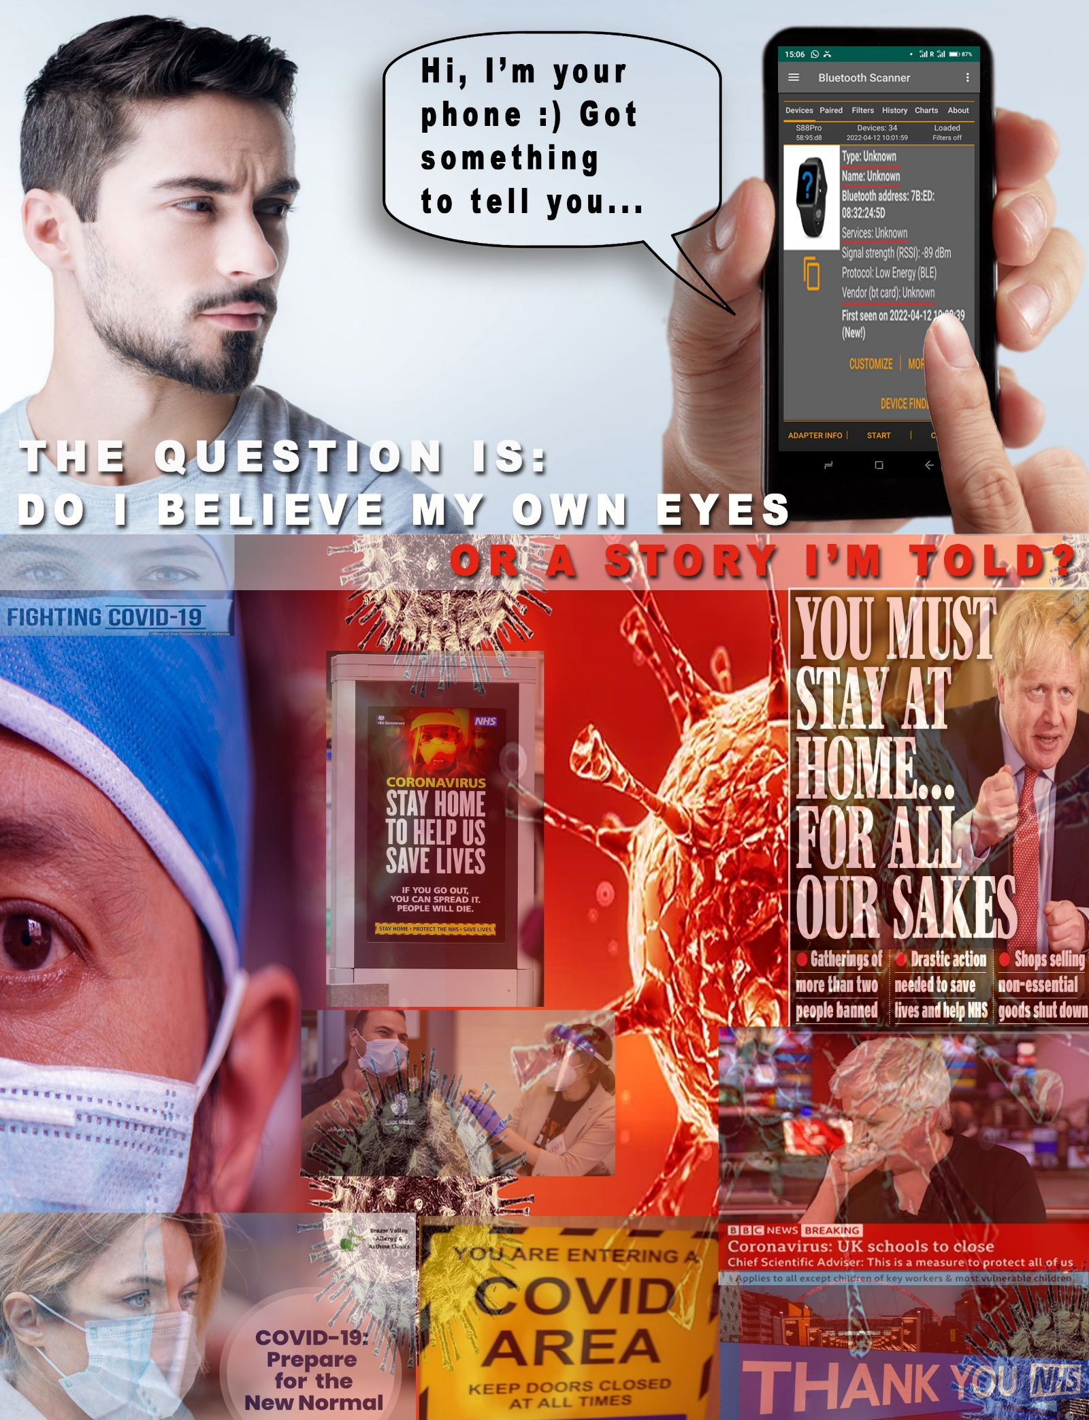And this is a visualization of the dilemma we face: What should we believe? Our own eyes, seeing the impartial evidence of an illegal Bluetooth device in the bodies of the vaccinated or the narrative presented to us by the WHO, the government, the NHS and the mass-media.

**REQUEST FOR INITIATING AN INVESTIGATION**

Based on the materials provided, I’d like to request for the following investigation actions and procedures to be initiated:

1. **Confirming the claims made in this request** that the bodies of the vaccinated emit Bluetooth signal by conducting the test according to the protocol described herein in attachment 1.  
   This test should be performed in 2 stages:  
   * **1st stage:** Confirming the existence of the illegal (unregistered) Bluetooth devices. This, all by itself, is the main criminal event I’d like us to concentrate on. Detecting what these devices are is only the second step of specification of details. There’s a triple confirmation/proof for this first stage. All the procedures for this triple confirmation are described in attachment 1.
     + **1st confirmation/proof**: Done through the mobile phone’s application menu.  
       When starting a scan for Bluetooth devices in the presence of vaccinated people (the Bluetooth signal has a range of about 50-100 metres) these devices appear as Name: Unknown, Type: Unknown, Service: Unknown, Vendor: Unknown. Usually there will be at least one or a few results of this kind at any public building, including the police stations. Otherwise, these Bluetooth devices are practically all over the city.
     + **2nd confirmation/proof:** Done through specialised MAC address look up websites of the type of <https://maclookup.app> . The MAC address check up for these Bluetooth devices on such websites brings a result that displays a message saying there’s no information about them.
     + **3rd confirmation/proof**: Done through checking of the major class code of the Bluetooth device which comes under the number of 7936. This class code is given to GPS locators or lab probes by the Bluetooth Specialised Interest Group. As these devices cannot be GPS locators (a test in airplane can bring easily more than 100 results of these devices and they certainly aren’t GPS locators) it means that these devices were produced just like lab probes and activated in our environment without any registration information regarding what they are, what they do and who is their service provider.   
         
       With this, in just under 30 minutes, anyone can authentically prove the existence of the illegal (unregistered) Bluetooth devices.
   * **2nd stage:** Identifying the source of the Bluetooth signal (identifying the device itself) connected to the MAC addresses of these devices.  
     This test can be completed in a matter of 10-20 minutes with any vaccinated individual when applying the protocol from attachment 1. Please, bear in mind that what is being recommended here as a tool of proof is a well established and approved by over 1 million users mobile phone application for locating/finding Bluetooth devices. They use this application mainly for finding their wireless Bluetooth earbuds or other small Bluetooth devices that can easily be lost and hard to find afterwards. If one million users find it easy to locate any Bluetooth device with this professional tool, certainly there’s no issue for any police officer to do the same and use it as a means for locating the illegal Bluetooth chip signals coming from the bodies of the vaccinated.   
     This test is proof that on top of **criminal event No 1** (the existence of illegal Bluetooth devices) there’s a **criminal event No 2** – a medical experiment being conducted on people without their knowledge and consent by injecting them with a Bluetooth operational system. Having in mind that the perpetrators of this criminal act were acquainted with the health consequences of the adverse effects of Bluetooth RF radiation and graphene oxide which is the hardware carrier of the Bluetooth MAC address and which is proven in numerous studies to be highly toxic to the human body we conclude there there’s a **criminal event No 3** for intentionally causing health risk for the vaccinated individuals. Having in mind that the Bluetooth connection allows for two way communication and that the graphene oxide nano-particles bind very well with the whole nervous system we conclude that there’s a clear intent for bio-hacking the vaccinated individuals with the goal of taking complete control over their minds, feelings, emotions and free will. This is **criminal event No 4**.   
       
     All of these criminal events can be proven in a matter of a few hours to a maximum one-two days as we can see from the very simple and fast procedures of the protocol in **Attachment 1**. In view of the urgency of this matter and the dimension of the crime committed, I urge you to take this matter seriously and conduct a quick and at the same time responsible investigation for gathering the required evidence before presenting the case to the prosecution. Your efficiency in this aspect will be highly appreciated by all the citizens.
2. If deemed necessary, to perform additional tests with professional equipment such as High Frequency Analyzers or others. However, let’s keep in mind that the mentioned protocol for testing with a mobile phone is quite sufficient to prove the presence of a Bluetooth signal in the body of the vaccinated. Additional research could only be of use for gathering more information regarding the amount of radiation or other information regarding adverse effects, yet the main claim can be proven with any mobile phone within a matter of minutes.
3. As a result of the confirmation of the statement that the signal of the illegal (not registered) Bluetooth devices is being emitted from the bodies of the vaccinated I’d like to ask you to immediately undertake actions for blocking all further vaccinations with the anti-covid vaccines. In this aspect please feel free to also use the numerous independent laboratory analysis of the vaccines mentioned in **Attachment 2**, as these tests conclude without any shadow of a doubt that there are numerous undeclared health threatening substances in the vials as well.
4. To initiate a procedure of prosecution through which all responsible individuals who imposed the implementation of the vaccinations without exercising the necessary quality control will be brought to justice. It is truly shocking that the most widely implemented vaccines in human history were never tested for any quality/substance control, which demonstrates a criminal level of negligance. Yet, the possibility of actively taking part in a premeditated plan of action by the government, the leaders of the mass media and the governing body of the NHS with the purpose of depopulating and turning the population into bio-robots through the Bluetooth chipping should also be investigated.   
   Also, similar steps should be undertaken towards the manufacturers themselves and the World Health Organization who‘s the main initiator for all lockdown measures and vaccinations and who should have taken all precautions regarding the health and safety of the populations of the world. Having in mind that Bill Gates, who is the owner of Moderna and shareholder in Pfizer is also the largest sponsor of the WHO it isn’t hard to suggest that the WHO might actually be an active participant in this crime rather than just a criminally negligent element in the implementation of this criminal undertaking.
5. The French research team (attachment 3) discovered that a participant in their test who had not been vaccinated but had been tested with a PCR test emitted a Bluetooth signal. The additional materials from independent analysis of PCR tests (attachment 4) provide a full explanation of this phenomenon. On the basis of these documents I’d like you to undertake the same actions about the PCR tests towards the respective authorities and individuals as with the vaccines.
6. I would like to ask you as well when the covid 19 vaccines are blocked to set aside a certain amount of vaccines to be distributed to a significant number of laboratories and individuals with microscopic equipment for visual analysis of the contents and dissemination of the information from these large-scale analyses. This distribution to laboratories can be done through the assistance of a citizens' initiative committee established for this purpose.  
     
   Why is this additional measure necessary?
   * There is a heavy information veil regarding the real content and purpose of the jabs that are wrongly named in society as covid19 vaccines. This is perfectly understandable, given the aims of the group that wants to impose them as compulsory on the entire population. Therefore, the more people see with their own eyes the real content of the vaccines, the more difficult it will become for this group to manipulate this vital information for the population.
   * Vaccines have a specific distribution status that prevents people from freely accessing them for analysis. Ordinary medicines can be purchased from the pharmacy and subjected to visual analysis by any person with a microscope, but vaccines, although not considered life-threatening substances or addictive drugs, are not available for free sale but are under strict individual accountability by the medical professionals. Therefore, special permission is needed to release a significant number of samples for analysis.
   * Our society as a whole allowed a criminal level of negligence in adopting an approach of absolute trust in the WHO, the government, the Ministry of Health, the regulatory authorities, the NHS and the vaccine manufacturers themselves, and therefore THERE WAS NOT EVEN ONE SINGLE INDEPENDENT ANALYSIS PERFORMED ON THE ACTUAL CONTENTS OF THE COVID VACCINES. At the same time, there were individual specialists from all over the world who lead by their own initiative managed to obtain samples and to carry out such in depth analysis and they tried to inform the public about the grave abuses with these jabs, which should not be referred to as vaccines, but rather as bio-weapons and means of converting people into bio-robots without their own will. Therefore, by distributing these vials to a significant number of laboratories for analysis, we could stimulate the personal initiative of these professionals in the future, so that the public has the opportunity to prevent potential similar future abuses.
   * Considering that graphene oxide is nowadays being added not only to the covid vaccines, but also to other vaccines, dental anaesthetics, medicines, food, hygiene materials, etc. (see attachment 7), by handing over such samples to a large number of laboratories, we will practically perform a nation-wide training of the professionals to detect graphene oxide and other unusual elements in the medications and substances for everyday use by the population. Thus once again we would stimulate their personal initiative to detect and neutralise hidden harmful ingredients and bio-weapons in various substances coming into use.
   * When the Allies took over Germany they made part of the population go through the nazi concentration camps in order for them to see with their own eyes what was actually hidden from the German citizens and what was allowed by them tolerating and supporting this government administration. When people from laboratories from all over the country see with their own eyes what’s the actual content of the vials of these bio-weapons that were promoted as life-saving vaccines this will change everyone’s thinking and behaviour towards more responsibility, alertness, control and real care for the safety of the substances that are allowed for mass use for the population.
7. Undertaking a full-scale campaign for thoroughly informing the population about the current problem. There are several reasons for this:
   * To give the population a chance for undertaking timely measures for the detoxification and treatment of the vaccinated and those who have done PCR tests.
   * To protect the rest of the population from these products and future once of similar kind
   * To stimulate the active screening for graphene oxide in other substances for mass use
   * To prevent the potential misuse of the psyche of the vaccinated by those in possession of the telecommunication systems for remote control of the human psyche. It may sound shocking, but current findings indicate that the vaccinated people, being exposed to such a serious manipulation risk, represent a group at high risk for creating social tension and unrest, hence the need for their active awareness as well as detoxification to remove the manipulation systems from the body.
8. Demand from the NHS to inform every vaccinated individual on the discovered undeclared substances in the vaccines, the Bluetooth chipping system included, and to inform them on the recommended procedures for protection from all adverse effects, once again including from the Bluetooth radiation and the toxic influence of the graphene oxide, the Bluetooth signal carrier.
9. Undertake immediate action for halting 5G in order to preserve the life and health of the vaccinated. Unlike 4G, the 5G network allows for the bodies of the vaccinated to be connected in much higher numbers directly to the telecommunication towers which allows for 24/7 high speed programming and influencing of the body/mind/emotions of the vaccinated. The Bluetooth signal has a range of only about 50-100 metres. The low density of 4G towers doesn’t allow for a huge impact on large masses of people, but the 5G high density of towers does. When connected directly to the towers the body/mind/emotion control over the vaccinated is way more powerful as the signal is much stronger, compared to the mobile phone Bluetooth signal. Further, the mobile phone Bluetooth signal can be turned off, while the 5G tower signal is constant. This means that all vaccinated who live in areas with activated 5G will be submerged in a very intensive 24/7 complete reprogramming influence. It’s worth reminding that the 5G roll-out happened very rapidly in lock-step with the pandemic measures, when everyone was in lockdown and the installation work of the 5G network went on.   
   We should be very clear that with the deadly combination of:
   * radiation from inside and radiation from outside the body of the vaccinated +
   * the possibility of the graphene oxide inside of the bodies of the vaccinated to react in an unpredicted way to different frequencies (see attachment 5) +
   * the direct high speed connection through which the 5G antennas allow for intensive reprogramming of the body/mind/emotions of the vaccinated

there’s only a really slim chance of survival for the vaccinated individuals in this environment. Sooner or later all of them will suffer very heavy injuries from the high radiation and their lives will be seriously threatened.

Thank you for your attention.

Kind regards,  
[Signed]

[Date]

**FOR EASE OF SHARING AND WORKING WITH THE LINKS, THIS DOCUMENT MAY BE SHARED AND DOWNLOADED FROM THE INTERNET:** [**https://bluetoothfreedom.com/index.php/documents/**](https://bluetoothfreedom.com/index.php/documents/)

**ATTACHMENTS:**

1. Protocol for detecting Bluetooth signal emissions from the bodies of the vaccinated by using a mobile phone
2. Independent laboratory tests from around the world for graphene oxide and other non-declared substances in covid vaccines
3. Study of the presence of Bluetooth signals in vaccinated, France: Project Bluetooth experience X
4. PCR tests analysis
5. The mass murder through graphene oxide is possible
6. Genocide through the covid vaccinations
7. Graphene oxide – biological weapon for depopulation and connecting people with internet is being spread in the environment
8. Dangers of 5G
9. What will happen if we don’t do anything about it?

**ATTACHMENT 1:**

**PROTOCOL FOR DETECTING BLUETOOTH SIGNAL  
IN VACCINATED WITH mRNA VACCINES AGAINST COVID  
BY USING A MOBILE PHONE**

1. 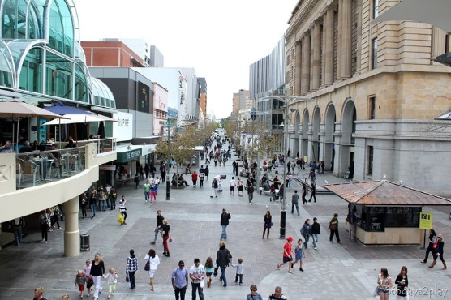**FIRST METHOD: QUICK TEST EVERYWHERE**This is the fastest and most universal method. It requires the purchase of the paid version of the Bluetooth device finding application, which costs about $ 1.5 for one year and $ 5 for ever.

**TEST LOCATION:  
everywhere, including in places with many people**

* + **TOOL FOR THE TEST**Mobile phone
  + **APPLICATION  
    For Android:** **“**[**Bluetooth Scanner - Bluetooth finder - pairing**](https://play.google.com/store/apps/details?id=com.pzolee.bluetoothscanner) **”**  by Zоltan Pallagi. There are other similar applications, but they are poorer in options and also user reviews recommend this application as the one with the highest performance accuracy. Here are examples of other applications: “[Microchip Bluetooth Data](https://play.google.com/store/apps/details?id=com.microchip.bluetooth.data)”, “[Find My Bluetooth Device](https://play.google.com/store/apps/details?id=com.findmybluetooth.headset.headphones.devices)”, “[Free EMF Detector, EMF Meter – ElectroSmart](https://play.google.com/store/apps/details?id=fr.inria.es.electrosmart)”, a.o.  
      
    **For iPhone:** ”[**Bluetooth BLE device**](https://apps.apple.com/us/app/bluetooth-ble-device-finder/id1465245157)**”** (recommended), “[BLE Scanner 4.0](https://apps.apple.com/es/app/ble-scanner-4-0/id1221763603)”, “[Find My Bluetooth Device Pro](https://apps.apple.com/py/app/find-my-bluetooth-device-pro/id1567509235)”, “[Find My Bluetooth Device](https://apps.apple.com/py/app/find-my-bluetooth-device-pro/id1468725639)”, “[Scanner Bluetooth](https://apps.apple.com/es/app/scanner-bluetooth/id1434984259) a.o.
  + **LOCATION  
    Everywhere, outdoors or indoors**This method allows for the test to be performed anywhere, including in places with many people, where there are many outcomes from the scanning and the procedure with the identification of the exact chip (MAC address) of the tested subject is highly impaired. The use of the **paid version** in this case is **mandatory**, because only in this version there is a possibility to **order the detected results by signal strength**. Thus, the first result that is at the top of the list of detected Bluetooth devices will be the chip (MAC address) we are looking for in the body of the vaccinated person.  
    Although the test can be performed anywhere, there is still a requirement for a minimum distance between the individual being tested and the rest of the people. This distance should be at least 3-5 metres (9-15 feet). There should be no other vaccinated individuals within a 3-5 meter (9-15 feet) range, as the signal coming from their Bluetooth devices may be ranked first, making it difficult to correctly identify the chip (MAC address) number.

**Faraday cage**

A second option as a location is to perform the test in a room which is isolated from any radio signals. These are the so-called Faraday cages. The room (tent, cabin, room) is insulated with a material that effectively isolates the Bluetooth signal. These are metals such as copper or nickel. The most practical in this regard are fabrics impregnated with copper or nickel or a combination of the two metals, which are produced specifically for this purpose for protection against electromagnetic fields and radio waves.

* + 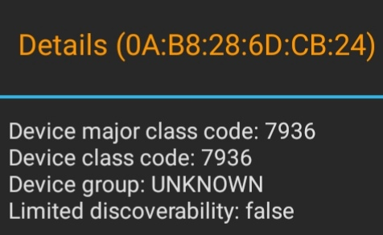**INVESTIGATED BLUETOOTH DEVICE - VACCINATION CHIP (MAC ADDRESS)**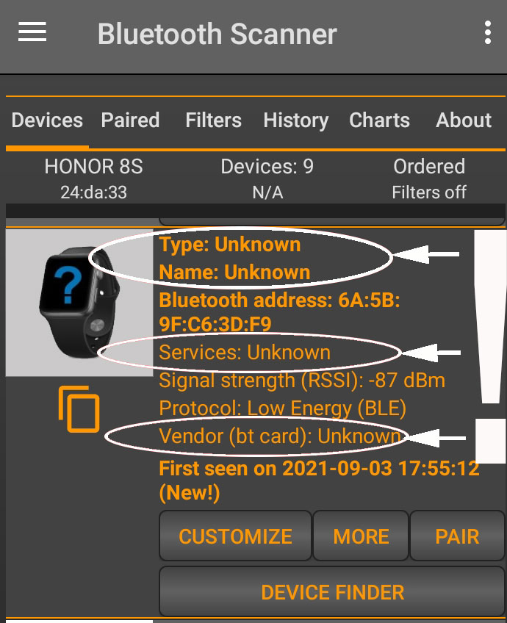TheBluetooth devices that are injected through the mRNA vaccines in the human body appear in the results of Bluetooth scanning applications as MAC addresses for which no additional information is found. For example, when such a device is detected by the application that is recommended for the Android testAndroid, “[**Bluetooth Scanner - Bluetooth finder - pairing**](https://play.google.com/store/apps/details?id=com.pzolee.bluetoothscanner) **”**  by Zоltan Pallagi, these devices appear with the following information:   
      
    **Name**: unknown, **Type**: unknown, **Service**: unknown, **Vendor**: unknown  
      
    If we click on the **MORE** button in this menu (MORE INFORMATION), the following window will appear with important additional information about the Bluetooth code of the device.  
      
    The menu shows that the code of the Bluetooth device is 7936: "**Device major class code: 7936**".

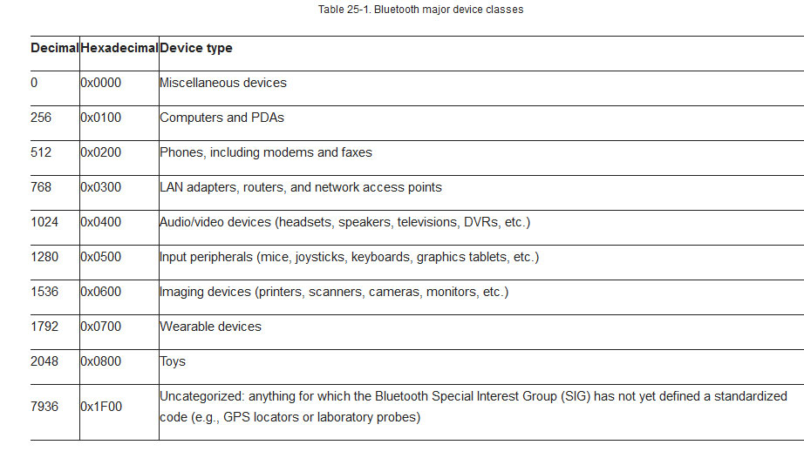

From this link,<https://flylib.com/books/en/1.134.1/the_bluetooth_protocol.html> , we can understand exactly what this code means. There is an international standard table for the different classes of Bluetooth devices and each Bluetooth device carries in its MAC address a code indicating the type of its class.

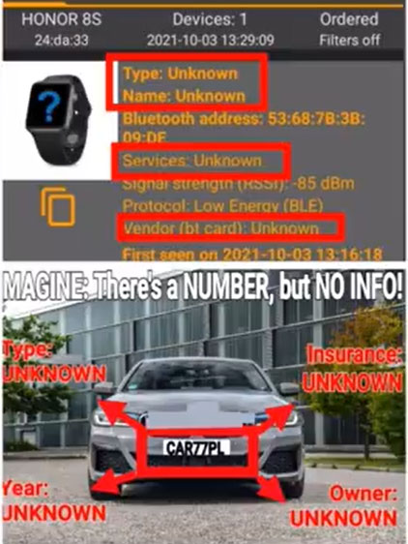From this table we see that these devices fall in the category “Uncategorised: anything for which the Bluetooth Special Interest Group (SIG) has not yet defined a standardized code (e.g., GPS locators or laboratory tests)”. In this case, it is clear that these are not GPS locators, but "laboratory samples", ie. devices that are manufactured unofficially (without being registered anywhere) and therefore fall into this category.

In addition, when the MAC address of these devices is entered into a dedicated website for identification of Bluetooth devices such as <http://maclookup.app> , again no information is returned by the search engine from the database. Such information must exist for each manufactured Bluetooth device. Here the situation is the same as with the vehicles and their registration numbers. When a vehicle registration number is entered on a website or computer identification system, then all information about this vehicle appears in the report. As the report on these devices does not provide any information about them, the conclusion is that these are illegal Bluetooth devices whose origin and function are unknown. These are the Bluetooth devices (chips) of the vaccinated.

* + 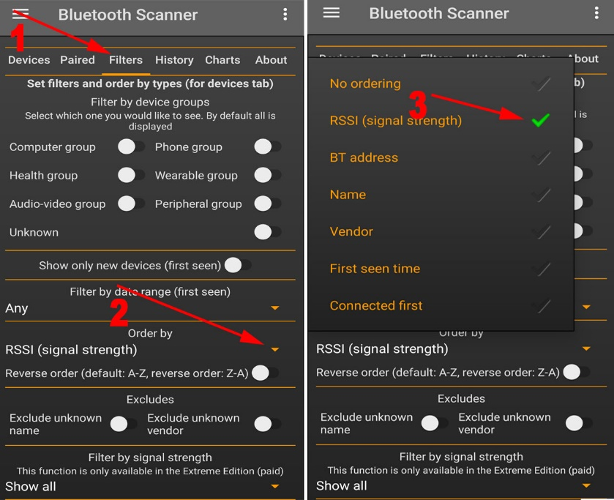**METHOD**Let's repeat: this method can be performed only with the paid version, as only this version allows ranking the results from the scan by signal strength. To do this we need to click on **Filters / Order by** and then on **RSSI (signal strength)**.   
      
    The vaccinated person stands in a place where there’s **no other vaccinated individual within at least 3-5 metres (9-15 feet) range**. This is important as we need to increase the chance for the first device on the list to be from the body of the individual being tested. The greater the distance between the individual being tested and everyone else, the better the accuracy and reliability of the test.

The phone should be as close to the body of the vaccinated person as possible and it also can touch the place of vaccination. Press the **START** button at the bottom of the screen to start scanning. When the results appear (5-10 seconds), we look for the first result on top of the list which is of the described type. We then press the **DEVICE FINDER** button to start tracking the device by the strength of the signal that it emits.  
In the new window you can see a graph depicting the strength of the signal. An audible signal with a button below the graph may be included at the wish of the tester. The higher the graph, the stronger the signal, i.e. the closer the phone is to the Bluetooth device. Experience has shown that the typical value of the graph at the maximum proximity of the phone to the vaccinated person and especially to the vaccination site is about -40 dBm. This value may vary, mostly to lower values.



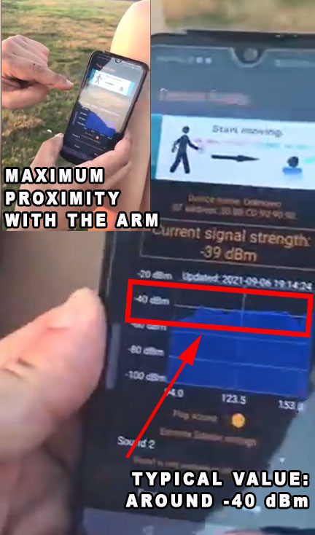If a signal with a similar level of power is detected, then the tester remembers the MAC address and changes his position by moving at least 100 metres (~300 feet) from the test site. For greater security, the tester should record the first 2-3 results (first, second and third MAC addresses) to eliminate the possibility of intertwining with other signals. A second scan is performed at the new location, which is at least 100 metres away from the first test. We are now looking for the same MAC address that came out on the first scan. If there is such a match, it is the chip of the vaccinated person. The **DEVICE FINDER** search function can be turned on again, so that the tester can confirm that the signal of the MAC address has remained the same (which means that this Bluetooth device is moving together with the body). Now this procedure can be repeated unlimited number of times each time going to a new place, which is at least 100 metres (~300 feet) from the previous one, to get out of the maximum operating parameter of Bluetooth devices in the last test and thus to prove, without any doubt, that the corresponding Bluetooth device is moving together with the body.

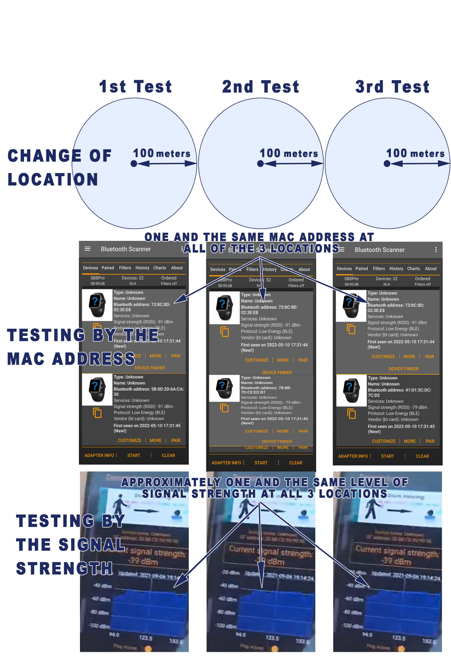Now there is only one last check left. It is to eliminate the possibility that this signal comes not from the body, but from the phone. This check is very simple. If the signal comes from the phone, it would be constant. That's why the tester has to move the phone away from his body one meter (3 feet), then two metres (6 feet) and then three metres (9 feet) to see if the graph decreases. If the graph varies (decreases as the phone moves away from the body and increases as it moves closer to the body), then this signal is coming from the body and not from the phone.

1. 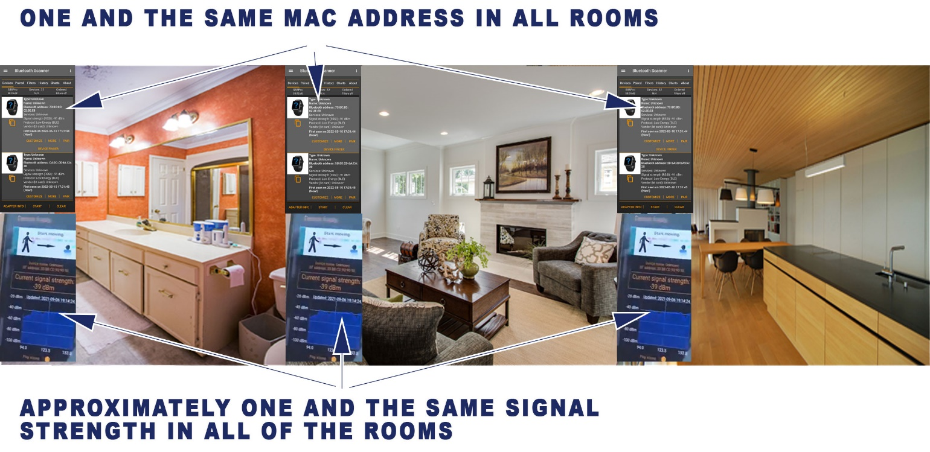**SECOND METHOD: QUICK TEST AT HOME**Everything mentioned about the F**IRST METHOD: QUICK TEST EVERYWHERE** applies here as well with two differences:  
   - **The location is at home  
   - The version of the application can also be the free one (without ranking the results by the signal strength)**.   
   As the free version does not allow the results to be sorted by the signal strength, it is necessary to find an environment where there are no other vaccinated people around within a radius of 100 metres (~300 feet) or the number of people should be limited enough for the results that appear on the app to be no more than 2-3. The small number of results allows for the quick and easy elimination of the remote signals and leaving just the most powerful one by checking the signal strength of each device separately.   
     
   The walls of the buildings create partial isolation for the Bluetooth signal and in most cases it is possible to quickly identify the Bluetooth device that corresponds to the specific vaccinated person, even if there is more than one result on the scanning app. At home, such results can hardly be more than 1-3, unless a person lives in a big city on the first floor of a busy street, but even then the scan results can be reduced to a minimum at night, when there are no people on the street next to the apartment. For the purpose of the test the vaccinated person enters each room of his home and while being there he scans with the application of the phone to determine which of the registered MAC addresses is permanent for each of the scans. In addition, the testing individual may also turn on the DEVICE FINDER function after each scan to check additionally the signal strength. These applications are designed to find lost wireless Bluetooth earbuds or other small Bluetooth devices, and their graphical interfaces indicate proximity to the subject that emits the corresponding Bluetooth. After determining the MAC address which is constant in each room and has the strongest signal, the testing individual goes out of the building and moves away from it at a distance of 100 metres (~300 feet) or more to make a new test. This way we eliminate the possibility that this signal is coming from somewhere within the home or from a neighbouring area, but it is moving together with the body of the vaccinated individual. If the same device with the same MAC address that was constant in all the rooms of our home reappears outside as well then we can conclude that this is the chip number (MAC address) from the vaccine.

**TEST LOCATION: at home**

The last step, eliminating the probability that the signal comes from the phone and not from the body, is done according to the scheme described above at the end of the first method. We simply move the mobile phone away from the body at different distances and see if the signal strength (the graphic) varies. If it varies, it means this signal does not come from the phone but from the body.

1. 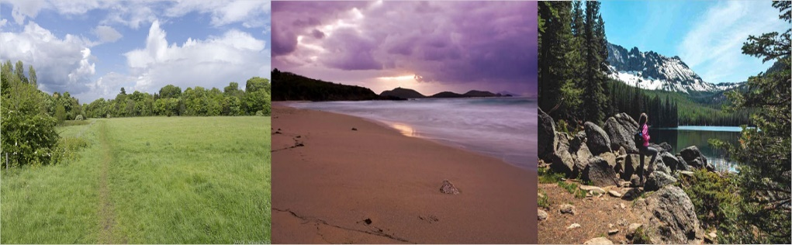**THIRD METHOD: TEST AT AN ISOLATED LOCATION WITHOUT OTHER BLUETOOTH DEVICES**Everything mentioned about the **FIRST METHOD: QUICK TEST EVERYWHERE** applies here as well with two differences:  
   **- The location is a place without other Bluetooth devices (field, beach, forest, mountain, etc.)  
   - The version of the application can also be the free one (without ordering the results by signal).**  
     
   The vaccinated person goes alone or with a non-vaccinated person to a place where there are no vaccinated and active Bluetooth devices within a range of 50-100 metres (150-300 feet). Such suitable places can be a park, forest, beach or other places where one can easily find a location where there are no people nearby. The reason for this is to exclude from the test any other Bluetooth devices for simplicity, accuracy and security of the result. As the Bluetooth signal has a maximum range of 50-100 metres (150-300 feet), no other active Bluetooth device other than the mobile phone used must be within this range.  
     
   When starting the scan, only one result of the searched type should appear on the menu. Now all that we should do is to check the strength of the signal and eliminate the possibility that this signal comes from the phone in the way already described in FIRST METHOD: QUICK TEST EVERYWHERE.  
     
   This method gives the highest psychological certainty for the final result of the test due to the visual perception of the fact that there is really no one around, and the unidentified device still appears.

**TEST LOCATION: isolated area – field, beach, mountain, wood**

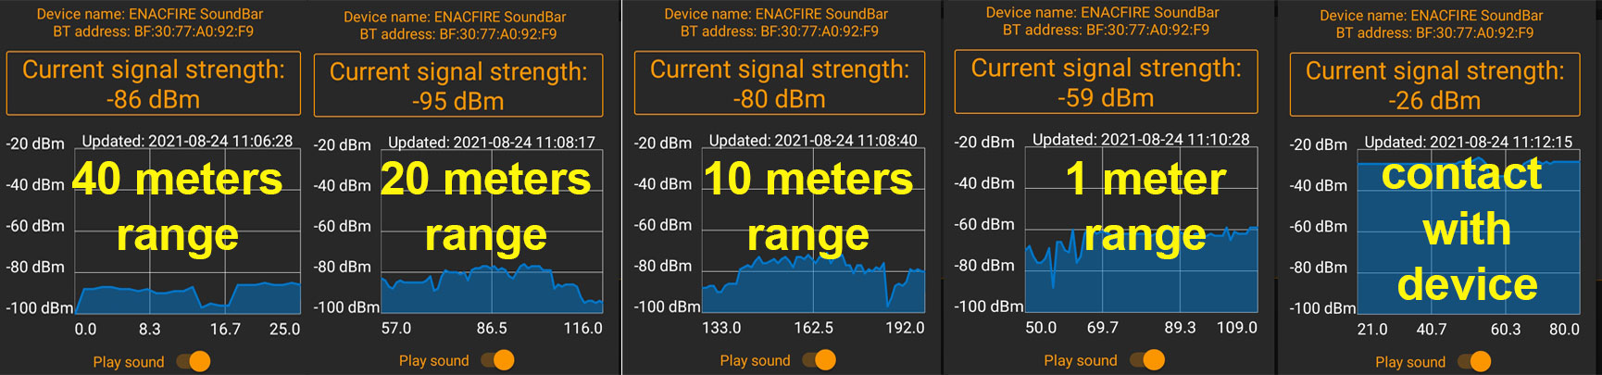

The signal strength as seen on the app for Android [**Bluetooth Scanner - Bluetooth finder - pairing**](https://play.google.com/store/apps/details?id=com.pzolee.bluetoothscanner) by Zоltan Pallagi at 10 metres, 1 meter and contact with a home Bluetooth speaker.

**IMPORTANT! See IMPORTANT NOTE 1 and IMPORTANT NOTE 2 !!!**

**IMPORTANT NOTE 1**: NOT ALL VACCINATED emit a Bluetooth signal. According to a French study, only about 45% of the vaccinated individuals tested had detectable Bluetooth emissions (Document: <https://tiny.cc/vaxchip_scires> , website: <https://operationxb.citizen-light.com/> , video: <https://www.bitchute.com/video/iWdCj5UitUEd/> ), while the Spanish doctor Lewis Benito reports that he found the signal in 96 out of 112 tested vaccinated patients (<https://dailyexpose.uk/2022/01/29/doctor-detects-mac-addresses-in-covid-vaccinated-individuals-with-bluetooth-applications> /). The reasons for this may be that some of the vaccines are placebo (saline), but there may be other reasons that are unknown at this stage.

**IMPORTANT NOTE 2**: While with standard Bluetooth devices the MAC addresses are constant and do not change, the Bluetooth devices of the vaccinated can change over time, ie. they may not be permanent. In the technical literature, this is known as spoofing - changing the MAC address. The reason for these variations is not known yet. The number may change, but the signal from the body remains constant and constantly generates new MAC addresses. The interval of change of these MAC addresses is also not specified yet, but it is at least a few hours or perhaps daily, which allows the test to be done successfully when using the same MAC address. The variations in these addresses do not affect the test results described in this protocol in any way. What remains constant is the presence of MAC addresses of unknown type and also the signal strength measured by the graph.

**VIDEO INSTRUCTION** for working with the most popular Bluetooth scanning application for Android, [**Bluetooth Scanner - Bluetooth finder - pairing**](https://play.google.com/store/apps/details?id=com.pzolee.bluetoothscanner)"by Zoltan Pallagi:  
Bitchute.com: [How to find the Bluetooth chip in vaccinated people](https://www.bitchute.com/video/OC7HW6FXTsPU/)

**FULL EXPLANATION** of the entire installed operating system in the vaccinated. This is a wonderful material summarizing about 20,000 hours of work of specialists from around the world who investigated the contents of the vaccines and the exact mechanism of action of the installed operating system that emits the Bluetooth signal and what is the purpose of the chipping together with the consequences . Bitchute.com [La Quinta Columna Confirms What’s in the Vaccine](https://www.bitchute.com/video/BQYZU2epFxlR/)

Second great video with in-depth explanations of the phenomenon with the MAC addresses: [Explanation of the MAC address phenomenon. Are vaccinated people hacked and controlled?](https://www.bitchute.com/video/4XmDOAeNMNBS/)  
  
This protocol has been developed by  
Momchil Pavlov   
  
April 2022  
Contacts:  
[manu@TheUKofLove.com](mailto:manu@TheUKofLove.com)   
  
This protocol can be downloaded and shared from:  
<http://TheUKofLove.com>

Different Bluetooth scanning applications   
with different visual interfaces

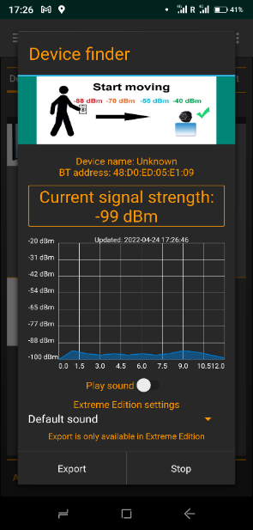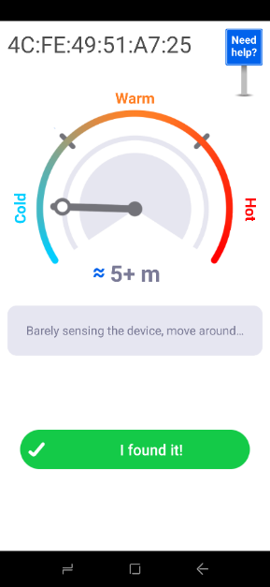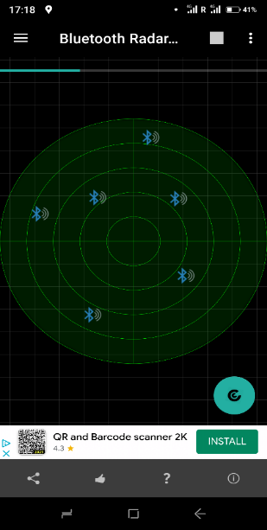

**ATTACHMENT 2:**

**INDEPENDENT LABORATORY TESTS FROM AROUND THE WORLD DETERMINING THE PRESENCE OF GRAPHENE OXIDE (THE BLUETOOTH SIGNAL TECHNOLOGY) IN SAMPLES TAKEN FROM VIALS OF THE mRNA VACCINES FROM ALL PRODUCERS: PFIZER, MODERNA, ASTRA ZENECA AND JOHNSON&JOHNSON**

**[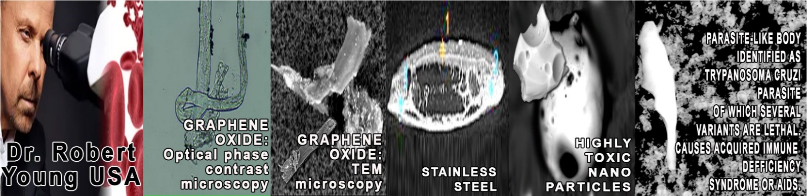](https://www.drrobertyoung.com/post/transmission-electron-microscopy-reveals-graphene-oxide-in-cov-19-vaccines)[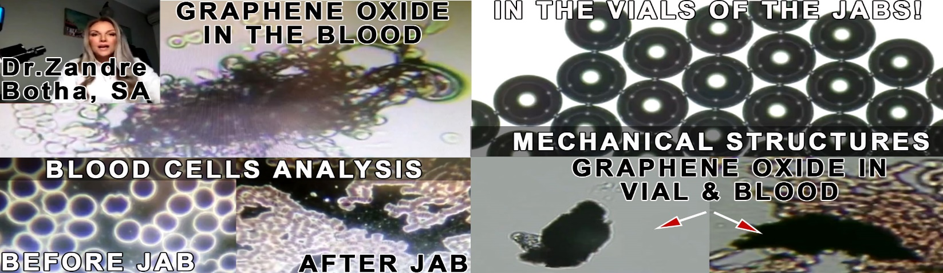](https://www.bitchute.com/video/6H4Jcl4Adue6/)Dr. Zandre Botha** from South Africa has examined both the vials of the covid mRNA vaccines and the blood of her patients before and after vaccination. Her reaction to the findings were *“I have never seen anything like this before… I cried when I saw what’s in the vaccines and the blood”*. She discovered graphene oxide and mechanical structures of unknown nature and observed the terrible consequences from the jabs in the blood. She shares her findings in her interview with Stew Peter on his show: **Bitchute.com**, [Horrific findings in the blood – Dr. Zandre Botha](https://www.bitchute.com/video/6H4Jcl4Adue6/)  
**Dr. Robert O. Young**, who is one of the top research and clinical scientists in the world with over 100 published, peer-reviewed articles has examined numerous vials from all vaccine producers using different instrumentation including Optical Microscopy, Bright-Field Microscopy, pHase Contrast Microscopy, Dark-Field Microscopy, UV absorbance and Fluorescence Spectroscopy, Scanning Electron Microscopy, Transmission Electron Microscopy, Energy Dispersive Spectroscopy, X-ray Diffractometer, Nuclear Magnetic Resonance.   
Dr. Young was able to identify not only the graphene oxide, but also parasites and a whole bunch of other non-disclosed materials like chromium, nickel, sulphur, chloride, nitrogen, bismuth, titanium, vanadium, iron, copper, silicon and aluminium. The presence of the carcinogenic and genotoxic **Poly-ethylene glycol (PEG)** and **ethylene alcohol** was also registered. The research document can be found on Dr. Young’s website, <https://www.drrobertyoung.com/post/transmission-electron-microscopy-reveals-graphene-oxide-in-cov-19-vaccines> , or as a video discussion:: **Bitchute.com**, [Dr. Robert Young GRAPHENE, ALUMINIUM, STAINLESS STEEL, LNP-GO CAPSIDS, PARASITES FOUND IN 4 VACCINES](https://www.bitchute.com/video/k5JasyhiwEGO/) .

**[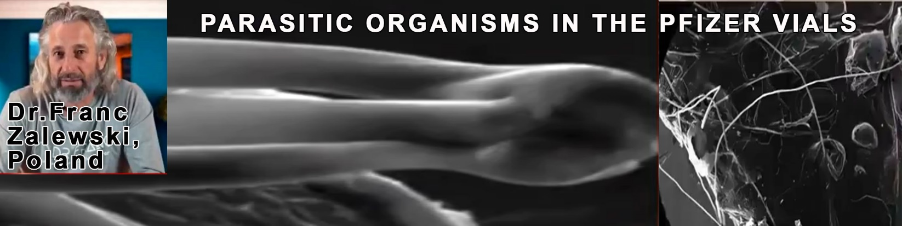](https://www.bitchute.com/video/mLjK0aU6IEHH/)[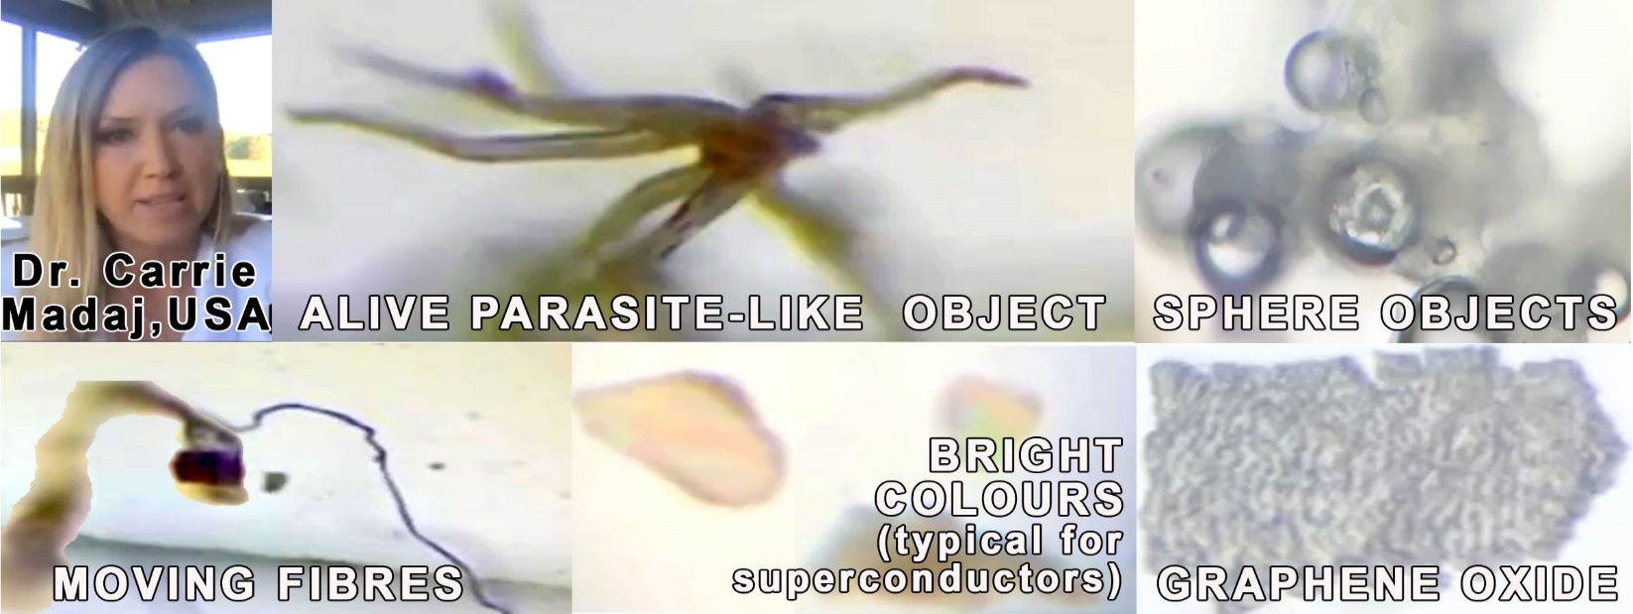](https://www.bitchute.com/video/w8bLbzjaPCQk/) Dr. Carrie Madaj, USA:** *“I cried harder than ever before when examining the vials!”* Dr. Carrie Madaj, who is a director of 2 independent laboratories, has examined multiple vials from the Moderna and the J&J vaccines and has discovered things she has never seen in her entire practice: She also found a parasite in two separate vials of Moderna, which significantly resembles the immortal Hydra Vulgaris. **Bitchute:** [**Dr. Carrie Madej: First U.S. lab examines "vaccine" vials, horrific findings revealed**](https://www.bitchute.com/video/w8bLbzjaPCQk/) **; Second video:** [**Possible third new parasite found by Dr. Carrie Madej in the Moderna vaccine and speculated to be th**](https://www.bitchute.com/video/ghGxW2sOsQve/) **Dr. Franc Zalewski** from Poland examined 5 Pfizer vials. Two of the vials were saline solution (placebo). One of the 5 vials had parasite-like creatures with a chemical structure of aluminium, carbon and bromine (mixture of synthetic and bio elements). They have a head and 3 tails with a proportion of 1 to ten for the head to the tails with the tails having a length of about 2.5 mm. These parasite-like creatures come in a form of dormant eggs which when put in contact with graphene oxide (detected in ALL mRNA vaccines) together with warm environment become active and one can see the head and legs sprouting and they also grow over the course of 4 days and afterwards they multiply. Pfizer vials require very low temperatures of preservation, which obviously helps the eggs to remain dormant while not in the body. The other 2 vials contained just graphene oxide**. Bitchute.com**, [DR. FRANC ZALEWSKI: THE THING](https://www.bitchute.com/video/mLjK0aU6IEHH/)

[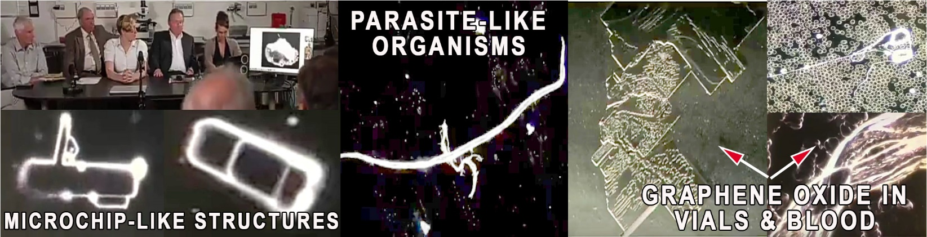](https://www.bitchute.com/video/47cFerxDTaEJ/)  
**An international medical conference held 20/09/2021 in Germany and Austria** revealed findings from numerous laboratory studies on the vials as well as pathology examinations. The microscopy has revealed micro-chip components, ribbons, wires, grids, nano-technology, large metallic looking ribbons, metallic rectangular/triangle/rhombus and knife shapes with sharp edges, square edge grids with unknown moving dots, complex multi-layered structures with square edges (most probably graphene oxide) that blood plates aggregate and stack around. The content moves, seems alive. The results of the investigation have led to legal and political demands for the immediate collection of information by the authorities in order to be able to assess the health risk posed to the population by the COVID-19 vaccines. The autopsies results confirm Prof. Dr. Peter Schirmacher's finding that among more than 40 corpses, he autopsied who had died within two weeks of COVID19 vaccination, approximately one-third were caused by the vaccination. **Bitchute.com**, [VIDEO and IMAGES of Covid-19 CONTENTS in VACCINES and VACCINATED BLOOD](https://www.bitchute.com/video/47cFerxDTaEJ/)  
  
**In the United Kingdom**, an independent laboratory test also confirmed the presence of graphene oxide in all vials tested: Moderna, AstraZeneca и Pfizer.  
<http://www.ukcitizen2021.org/Case_Briefing_Document_and_lab_report_Ref_AUC_101_Report%20.pdf> (p.12)

**[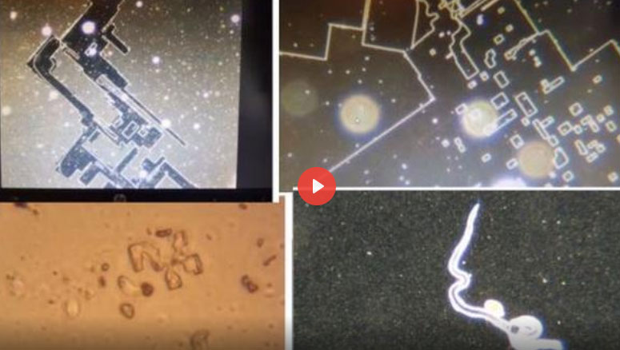](https://www.bitchute.com/video/bGQXA2DBfGvS/) A doctor and lawyer from New Zealand** confirmed the findings in other independent laboratories around the world.

[Pfizer VACCINE EXAMINED under MICROSCOPE - New Zealand Dr. and Lawyer present findings](https://www.bitchute.com/video/bGQXA2DBfGvS/)

[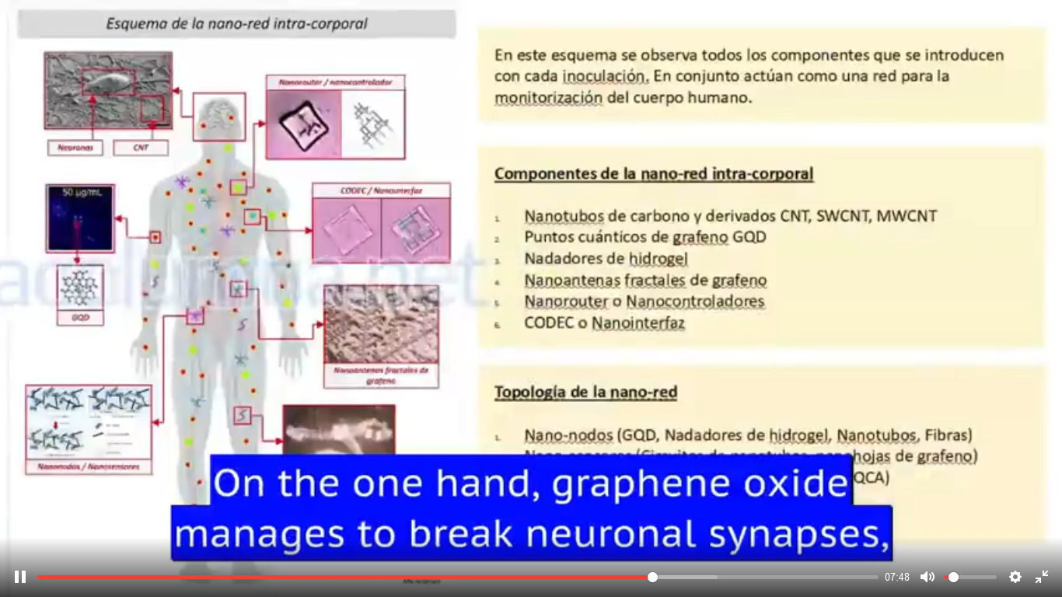](https://www.bitchute.com/video/AlpWsETsUKWS/)A full explanation of the entire operating system found in the vaccines can be seen in this video:  
**Bitchute.com**: [La Quinta Columna Confirms What’s in the Vaccine](https://www.bitchute.com/video/BQYZU2epFxlR/) as well as here: [Explanation of the MAC address](https://www.bitchute.com/video/4XmDOAeNMNBS/) .

[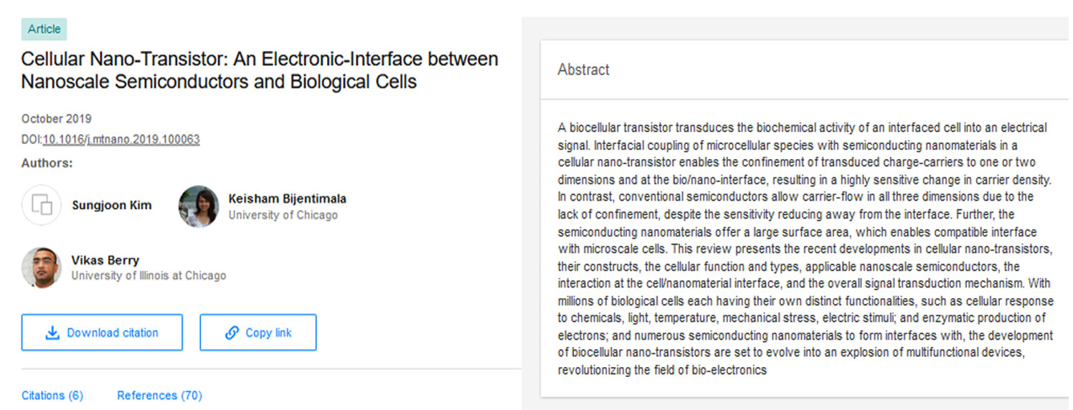](https://www.researchgate.net/publication/336735087_Cellular_Nano-Transistor_An_Electronic-Interface_between_Nanoscale_Semiconductors_and_Biological_Cells)If you type the following keywords “nanoscale semiconductors and biological cells” in the <https://www.researchgate.net> search engine there will appear [a number of publications on this subject](https://www.researchgate.net/search/publication?q=nanoscale+semiconductors+and+biological+cells). Here’s a publication from 2019. Cellular Nano-Transistor: [An Electronic-Interface between Nanoscale Semiconductors and Biological Cells](https://www.researchgate.net/publication/336735087_Cellular_Nano-Transistor_An_Electronic-Interface_between_Nanoscale_Semiconductors_and_Biological_Cells)

**ATTACHMENT 3:**

**DETECTING BLUETOOTH EMISSIONS IN, FRANCE.  
PROJECT BLUETOOTH EXPERIENCE Х**

Translation made with www.deepl.com/translator  
 **ABSTRACT**Objectification of the existence of detectable MAC addresses in the Bluetooth frequency range following an inoculation of COVID antigen therapy and COVID detection PCR test.

**TEAM**Germán Sarlangue, Julien Devilleger, Philippe Trillaud, Steve Fouchet, Lidwine Taillasson, Grégory Catteau

**LINK TO THE SOURCE**<https://ln5.sync.com/dl/195df4a10/5ab9apq6-q5vgawam-vgr3ktt9-7zr985rh>

**1/ FOREWORD**Since April 2021, rumours have spread on social networks concerning the appearance of bluetooth-type signals following one or more anti-covid injections offered by pharmaceutical companies Astra Zeneca, Pfizer, Johnson&Johnson and Moderna. Numerous videos have circulated which seem to highlight the appearance of disturbing phenomena, namely:

* + 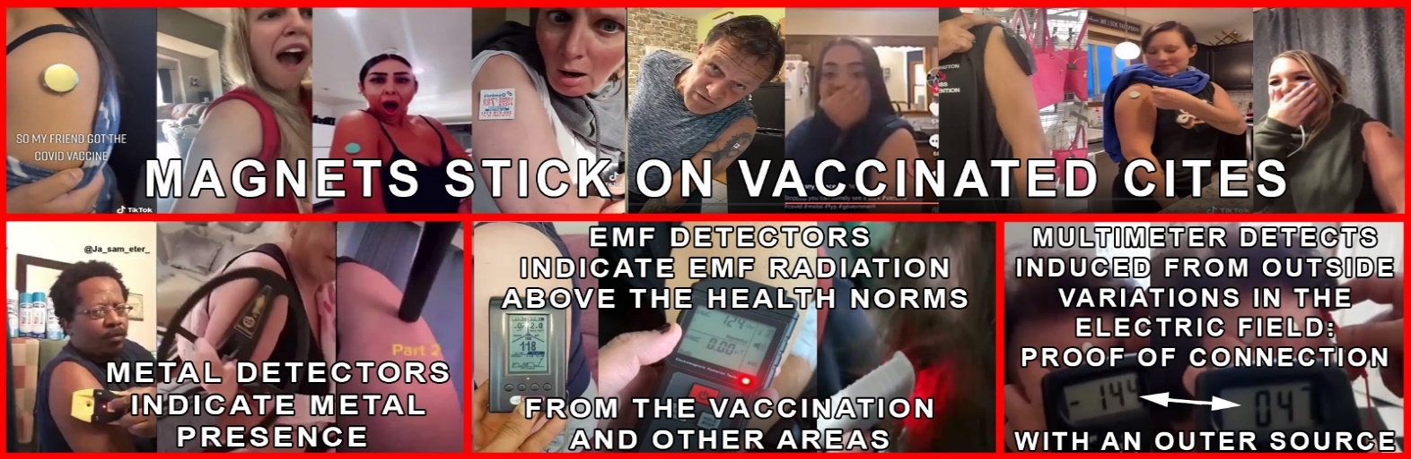Unexplained magnetisation phenomena on various sites of the bodies of injected people (which led to an explosion of publications on TikTok grouped around a community movement, The Magnet Challenge). <https://www.youtube.com/watch?v=lYi3sjRZviA>)

(A number of videos on the Internet demonstrate strange vaccination phenomena such as magnetism, metal detection at the vaccination site with a metal detector, EMF radiation detection and even variations in the electric field in a multimeter test. [MagnetGate](https://www.bitchute.com/video/aq1aTigWg0JF/) )

The appearance of signals during a scan performed on the body of an inoculated person via animal microchip detection equipment commonly used by veterinarians. <https://www.tiktok.com/@jasmine_0708/video/6974140084870237445>

All these rumours were denied by the mainstream media and news agencies, while in the alternative networks numerous empirical experiments by ordinary citizens seemed to show the opposite. <https://www.reuters.com/article/factcheck-astrazeneca-bluetooth-idUSL2N2NC2G9>  
[https://www.20minutes.fr/sante/3067959-20210623-coronavirus-non-vaccins-permettent-etredetecte-bluetooth-gare-videos-trompeuses](https://www.20minutes.fr/sante/3067959-20210623-coronavirus-non-vaccins-permettent-etre-detecte-bluetooth-gare-videos-trompeuses)

Nevertheless, empirical citizen experiences are multiplying::  
<https://henrymakow.wordpress.com/2021/09/17/le-vaccin-contient-votre-code-barres/>   
<https://echelledejacob.blogspot.com/2021/11/vaccines-et-puce-bluetooth-mise-jour.html>  
<https://www.youtube.com/watch?v=q1VCRZNaHLE>  
<https://odysee.com/@Hemeroteca:f/DrDeBenito-mac-address--:7>  
<https://odysee.com/@Pigeon_Pige-TouT_Traduction:6/bluetooth-2:e>

In France, the first documented experiment on the subject was the subject of an article published in Agoravox  
<https://www.agoravox.fr/tribune-libre/article/operation-dent-bleue-235064>

However, as Jérôme R., who is responsible for the publication of the article, points out, even if the results obtained are questionable (many unidentified MAC addresses appear), it would be wrong to draw a hasty conclusion.

Indeed, the field of experimentation was a public garden from which many legitimate signals could emanate from devices not taken into account and its detection equipment (an Archos mobile phone running under Android) could also be the object of potential flaws in the detection. Of course, these experiments, which only show a final result, were not part of any assumed protocol and did not in any way demonstrate the reliability of the results.

In parallel, numerous studies have been carried out to establish the presence of graphene oxide or one of its derivatives in the composition of the vaccine. It is important to understand that graphene oxide has been the subject of a plethora of studies around its unique physicochemical and electromagnetic properties. Commercial applications are already available:  
<https://www.youtube.com/watch?v=SMB2I_bq0zc&feature=youtu.be>

At the same time, there are official patent applications for the development of nanotechnologies implanted in the human body, such as nanosensors, or for various devices using electromagnetic radiation for all kinds of potential applications.

[https://patents-google-com.translate.goog/patent/US4717343? _x_tr_sl=auto&_x_tr_tl=fr&_x_tr_hl=fr](https://patents-google-com.translate.goog/patent/US4717343?_x_tr_sl=auto&_x_tr_tl=fr&_x_tr_hl=fr)  
[https://patents-google-com.translate.goog/patent/US3951134? _x_tr_sl=auto&_x_tr_tl=fr&_x_tr_hl=fr](https://patents-google-com.translate.goog/patent/US3951134?_x_tr_sl=auto&_x_tr_tl=fr&_x_tr_hl=fr)  
[https://patents-google-com.translate.goog/patent/US5159703? _x_tr_sl=auto&_x_tr_tl=fr&_x_tr_hl=fr](https://patents-google-com.translate.goog/patent/US5159703?_x_tr_sl=auto&_x_tr_tl=fr&_x_tr_hl=fr)  
[https://patents-google-com.translate.goog/patent/US5507291? _x_tr_sl=auto&_x_tr_tl=fr&_x_tr_hl=fr](https://patents-google-com.translate.goog/patent/US5507291?_x_tr_sl=auto&_x_tr_tl=fr&_x_tr_hl=fr)  
[https://patents-google-com.translate.goog/patent/US6052336? _x_tr_sl=auto&_x_tr_tl=fr&_x_tr_hl=fr](https://patents-google-com.translate.goog/patent/US6052336?_x_tr_sl=auto&_x_tr_tl=fr&_x_tr_hl=fr)  
[https://patents-google-com.translate.goog/patent/US6506148B2/en? _x_tr_sl=auto&_x_tr_tl=fr&_x_tr_hl=fr](https://patents-google-com.translate.goog/patent/US6506148B2/en?_x_tr_sl=auto&_x_tr_tl=fr&_x_tr_hl=fr)  
[https://patents-google-com.translate.goog/patent/US10300240B2/en? _x_tr_sl=auto&_x_tr_tl=fr&_x_tr_hl=fr](https://patents-google-com.translate.goog/patent/US10300240B2/en?_x_tr_sl=auto&_x_tr_tl=fr&_x_tr_hl=fr)  
[https://patents-google-com.translate.goog/patent/US5629678A/en? _x_tr_sl=auto&_x_tr_tl=fr&_x_tr_hl=fr](https://patents-google-com.translate.goog/patent/US5629678A/en?_x_tr_sl=auto&_x_tr_tl=fr&_x_tr_hl=fr)

Finally, in the face of the secrecy of the composition of the injections as well as the negotiated impunity of the pharmaceutical laboratories with regard to the possible undesirable effects linked to the injections, certain studies have emerged highlighting some troubling elements:

[https://corona2inspect.blogspot.com/2021/11/identificacion-patrones-vacunas-coronavirusnanorouters.html](https://corona2inspect.blogspot.com/2021/11/identificacion-patrones-vacunas-coronavirus-nanorouters.html)  
<https://www.researchgate.net/publication/356507702_MICROSTRUCTURES_IN_COVID_VACCINES_i>  
<https://corona2inspect.blogspot.com/2021/09/redes-nanocomunicacion-inalambricananotecnologia-cuerpo-humano.html>

<https://drive.google.com/file/d/1M5T_pa4d87vznN0r0IUpjrSb07sqO9vh/view?usp=drivesdk>

**2/ HARDWARE ENVIRONMENT AND TECHNICAL CONFIGURATION**

For this experiment it was chosen to work with an Ubertooth one antenna from Great Scott Gadgets::

* RP-SMA connector (for connecting the Bluetooth antenna)
* CC2400 Full duplex 2.4 GHzwireless transmission module CC 2591 RF front end module
* LPC175x ARM Cortex-M3 microcontroller
* USB 2.0 Full-speed connection
* Bluetooth and Bluetooth LowEnergy support
* Approximate amperage 220mA

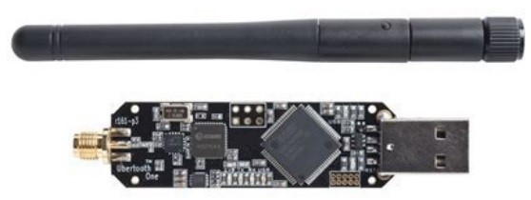 It can send and receive packets at 2.4 GHz, which is the frequency of Bluetooth, but it can also view real-time Bluetooth traffic in monitor

mode. The device is comparable to a class 1 Bluetooth module, i.e. it has a

maximum power of 100 Mw (20 dBm) and a range of 100 metres without obstacles.

As far as the laptop is concerned, we chose a::   
- Intel Core I7-6600U processor (2.6 Ghz)

- RAM Memory: 16 GB DDR3

- Intel HD Graphics 520

- 240 GB SSD hard drive

The Bare metal installer 2021-3 version of Kali linux has been downloaded from: <https://kali.download/base-images/kali-2021.3/kali-linux-2021.3-installer-amd64.iso.torrent> as an iso file..

It was mounted on a standard 32 GB USB stick as a bootable disk image via the Rufus application <https://rufus.ie/fr/> .

What follows are installation instructions that are highly specialized and can be found in the original study document.

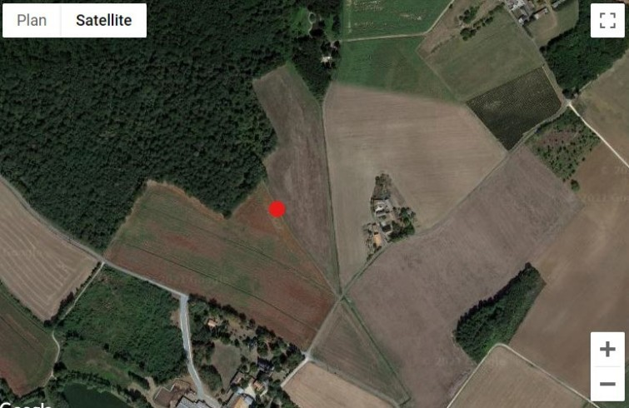**3/ PRELIMINARY TESTS**

On 16/10/2021 at around 09:30 we carried out preliminary tests in an open field near the commune of Chabournay.   
  
The exact GPS coordinates of the site are:: 46°44'49.6''N 0°13'32.0''E.

The red dot marks the location where the detection post has been installed.

**3/1 PRE-TESTING PROCESS**

The antenna is connected, the servers activated. The protocol starts.

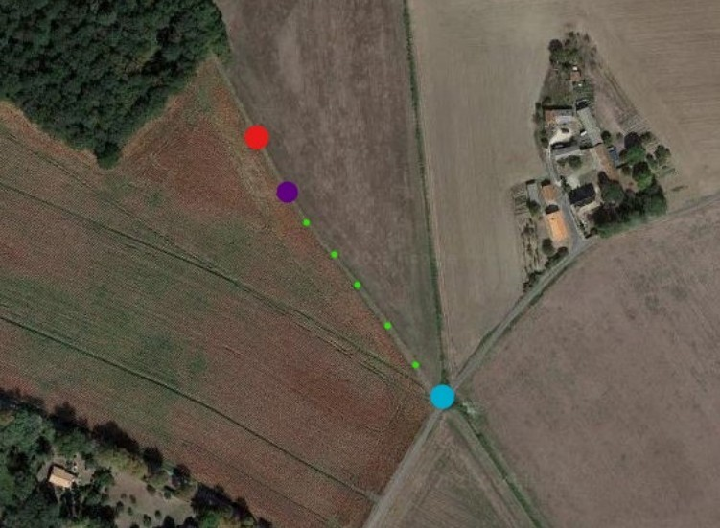

Candidates start from the blue dot and follow the path (small green dots) towards the detection post (red dot). In a number of cases Bluetooth signals activate spontaneously at a distance of about 30 metres from the station (purple dot) The pre-test is conclusive and functional, allowing the validation of the test protocol planned for the following day.

**3/2 COURSE OF THE EXPERIMENT**The experiment will take place on 17/10/2021 in the commune of Cognac La forêt. A Cartoradio location gives the

following topography:  
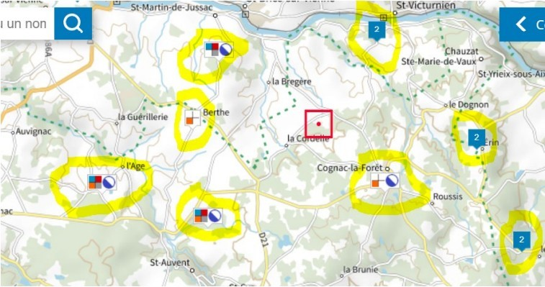

The different highlighted sites correspond to relay antennas whose characteristics are available [here](https://www.cartoradio.fr/index.html#/cartographie/all/lonlat/0.98220/45.84740). A reconnaissance of the area leads us to install the detection equipment at the location indicated on the map.

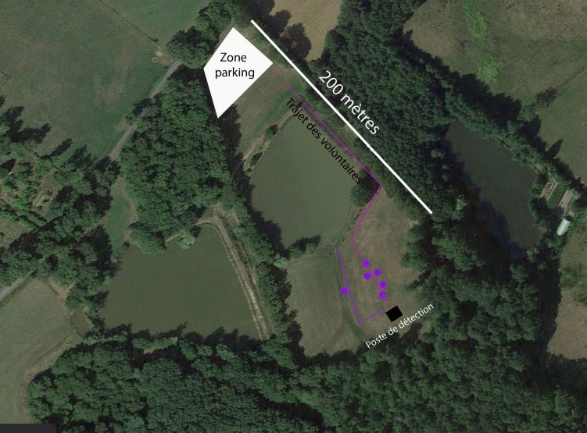

**3/2/1 TECHNICAL PREPARATION**

The cameras are carefully set up and the personnel likely to operate in the detection zone are tested one after the other. They were given the following instructions:

* No mobile phone
* No connected watch
* No connected devices (headset, headphones,...)

Once these prerequisites have been met, they take the test several times in a row:

* Alone and without equipment
* Alone with equipment switched off
* Alone with camera equipment on.

The cameras and sound equipment are wired and the transmission systems are all disabled.

Due to these settings, two additional passes are made to objectify the total absence of signal detected.

**3/2/2 COURSE OF THE EXPERIMENT**

At the same time, applicants are grouped at the reception area (near the parking area) and given a questionnaire to complete. They all receive the same instructions and one person physically checks the execution of the instructions. One by one they follow the route identified in purple as the "volunteer route". The purple dots mark the locations where the different signals appeared.

**3/2/3 RESULTS OBTAINED**

The table with the exact measurements of each individual participant can be found in the original..

**3/3 GROSS ANALYSIS OF RESULTS**

The first conclusions of the experiment are reported in the following summary tables:

|  |  |  |  |  |
| --- | --- | --- | --- | --- |
| **RAW DATA** | | **EMISSION** | **ABSENCE OF EMISSION** | **DOUBT** |
| Number of people | 37 | 7 | 30 | 2 |
| Injected | 15 | 6 | 9 | 2 |
| Non-injected, PCR tested | 2 | 1 | 1 | 0 |
| Non-injected, non-tested | 20 | 0 | 20 | 0 |

The data in percentage

|  |  |  |  |  |
| --- | --- | --- | --- | --- |
| **PERCENTAGE** | | **EMISSION** | **ABSENCE OF EMISSION** | **DOUBT** |
| Number of people | 37 | 19% | 81% | 5% |
| Injected | 15 | 40% | 60% | 13% |
| Non-injected, PCR tested | 2 | 50% | 50% | 0% |
| Non-injected, non-tested | 20 | 0% | 100% | 0% |

This experimentation thus indisputably highlights the following elements:

* No non-inoculated, untested person gives a signal
* A few injected persons give signals in about 40% of cases
* A few non-inoculated, tested persons give signals in about 50% of the cases.

**3/4 ADDITIONAL EXPLORATION**

In view of these experiences, several uncertainties remain:

* Measurement time
* Potential interactions with the electromagnetic environment
* Social interactions
* Detectability of signals from non-injected test subjects

A new experiment was therefore undertaken on 07/11/2021 at a different location.

This new location has the advantage of troglodyte caves that are sufficiently airtight to act as a Faraday cage.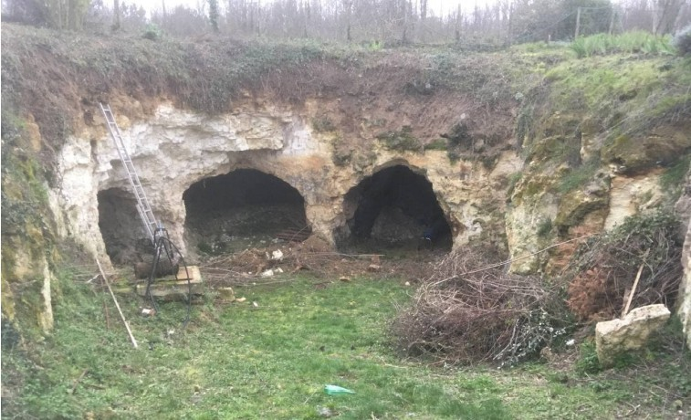

**3/4/1 COURSE OF THE EXPERIMENT**On the first day the applicants were grouped together in a reception tent located on the upper part of the grounds more than 50 metres from the main entrance to the caves. The same instructions were given to them and the same strict vigilance was observed regarding compliance.

The distribution of applicants is as follows:

* 2 non-inoculated persons not tested
* 7 non-inoculated and tested persons
* 8 inoculated persons

A scan was carried out upstream inside the cave which showed a complete absence of Bluetooth traffic. The experiment takes place over two days:

**Day 1**There were 16 candidates present, distributed as follows:

* 2 non-inoculated persons not tested
* 6 non-inoculated and tested persons
* 8 inoculated persons

**Day 2**A non-inoculated and tested candidate was present. During these two days, the protocol applied is the following: Each candidate identifies themselves beforehand, in the tent. It is given a passage number. Every 20 minutes, a new candidate enters the cave where the scanning equipment has been installed and spends 20 minutes in the cave in order to detect a Bluetooth signal.

**3/4/2 EXPERIMENTS RESULTS**

**DAY 1**The candidates follow each other one by one. Only one MAC address is recorded: c4:df:27:f9:45:b5 . This is a doubly inoculated person.

**DAY 2**Only one candidate is present.. This is a person who has not been inoculated but has been tested by PCR (about 70 tests). Two Mac addresses appear simultaneously with almost identical references::  
4c:64:fd:da:fc:5f  
4c:64:fd:da:fc:9f  
In view of these results, we decided to continue the experiment. We turned the kismet server off and on. Captured signals no longer appear. We then went up to the plateau, under the tent, to test whether the signal would reactivate in a less protected environment. After 20 minutes of scanning no new signal appears.

We then asked the candidate to perform some physical exercises in order to verify a potential relationship between the body energy released by the candidate and a signal activation. After 20 minutes of scanning no new signal appears. We then asked a member of the team to gradually bring the mobile phone (Samsung) closer to the candidate to start checking for possible human-mobile phone interactions. No particular activity is detected when the phone is switched off. We repeated the experiment with the laptop in aeroplane mode. No particular activity is detected when the phone is in aeroplane mode. We repeated the experiment with the laptop in normal mode, bluetooth off. No particular activity is detected with the laptop in this configuration. We then activated the Bluetooth of the candidate's device. Bluetooth is detected, strictly normal traffic takes place, no suspicious MAC addresses appear.  
We then brought a second mobile phone (Also a Samsung) in normal mode, Bluetooth enabled. The devices communicate consistently with each other and no additional MAC addresses appear. Finally, in order to retrieve additional data, we continued to scan the traffic in the ambient environment, the candidate reintegrating the interior of the house in which were present 6 mobile phones in various conditions, an internet box with 2 wifi relays. We gradually turned off all the devices and then turned them back on one by one. It should be noted that of all those present only the candidate was tested by PCR. We note strictly normal traffic which corresponds to data exchanges between the different devices. There is also a significant number of invalid frames and unknown or uninterpretable packets with the Wire Shark software. We can therefore reasonably conclude that both the inoculated and the tested persons emit signals outside of any activation induced by an environmental electromagnetic field. However, these signals do not seem to be constant over time and their activation seems to depend on conditions that remain to be defined. (See conclusions and perspectives below).

**4/ EXPLOITATION OF RAW DATA**

**4/1 REMINDER OF THE CONTEXT**

During these experiments, we were able to observe and capture the exchanges (frames) emitted by unknown devices in places without any signals. In these experiments, as we did not have the necessary equipment for a full analysis, we performed a scan using a scanning mode with Ubertooth equipment. This map allowed us to scan all the frequencies used by the Bluetooth protocol. BTLE version 5 has 40 channels which were scanned in turn at regular intervals. The Bluetooth BTLE protocol is commonly used for many applications and we therefore set out to explore the classic ways of building on this technology. Many resources exist.

For example: <https://www.bluetooth.com/bluetooth-resources/intro-to-bluetooth-low-energy-coded-phy/>

**4/2 VOLUME OF INFORMATION RETRIEVED**

(Highly specialised technical information. See the original document <https://tiny.cc/vaxchip_scires> )

**4/3 FIRST PROTOCOL ANALYSIS:**

Among these frames, most of which are malformed according to the frame formats recognised by the Wire Shark software, which indicates at least a customisation of the protocol stack, we find packets consistent with the Bluetooth protocol for messages of type::

* BT MeSH messages
* BTLE AUX_SCAN messages
* AUX_CONNECT messages
* Unknown messages (or messages not recognised and interpreted by Wire Shark)

**4/3/1 PACKETS CORRESPONDING TO BT MESH MESSAGES**

(Highly specialised technical information. See the original document <https://tiny.cc/vaxchip_scires> )

**4/3/2 PACKETS CORRESPONDING TO BTLE AUX_SCAN MESSAGES**

(Highly specialised technical information. See the original document <https://tiny.cc/vaxchip_scires> )

**5/ CONCLUSIONS AND PERSPECTIVES**

From these results we can say that a significant percentage of injected persons and, to a lesser extent, non-inoculated persons tested by PCR tests emit alphanumeric signals in the frequency range corresponding to that of Bluetooth use.

This percentage will need to be refined by future studies to highlight the potential impact of the following factors:

* Brand of the injected product
* Profile of the applicant :
  + ➢ Number of injections

received

* + ➢ Date of last injection

Numerous frames appear in connection with these signals which are currently uninterpretable by the Wire Shark software. A common feature of these frames is the low dBm level. Among the probable explanations for the incomplete or even uninterpretable character of these frames, some hypotheses can be explored:

A different modulation than the one usually used for classical BTLE protocols

- A series of actions scheduled over channel hops (within and/or outside the Bluetooth frequency range).

There is a very clear prominence of signals emitted in an ambient environment compared to signals emitted in an environment without electromagnetic activity. Additional tests will therefore have to confirm this trend and identify the triggering factors of the signals in order to specify their nature and, above all, their functionality(ies). These alphanumeric signals are not constant in time and their appearance is brief. There may be a programmed schedule (fixed or random, depending on triggers such as social interactions) behind these appearances. Many more experiments will undoubtedly be necessary to acquire sufficient data to identify redundancies, cycles, patterns...

This video demonstrates that the Bluetooth signals can be detected not only with living bodies, but also with the bodies of the vaccinated who have passed away. The guy on the video detects on his phone perhaps hundreds of these devices while walking around in a huge cemetery in the US during the night.   
Bitchute.com: [Bluetooth signals from beyond the grave. Covid19 shot Bluetooth signals in the graveyard!](https://www.bitchute.com/video/nmhx46RxBgGP/)

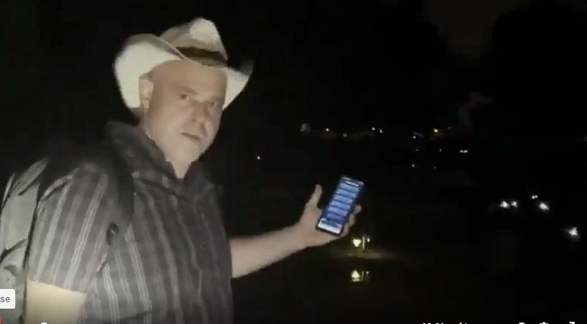

**ATTACHMENT 4**

**ANALYSIS OF TEST STICKS FROM SURFACE TESTING IN THE SLOVAK REPUBLIC - CONFIRMATION OF GENOCIDE**

key words – 1) nylon, 2) Darpa Hydrogel, 3) lithium, 4) pineal gland

The analysis was performed in the months November 2020 to March 2021 on test sticks in sets. SD Biosensor, Abbott and Nadal in an unnamed hospital laboratory from Bratislava, Slovakia. The test swabs were from the sets used in surface testing in Slovakia and in hospitals.

Anyone who has at least a standard school microscope and a test microscope can verify the information regarding the test swabs published here. All information about test swabs, Darpa Hydrogels, and lithium is publicly available in scientific and corporate work. Links to some are at the end of the document.

**From this information it is clear that test sticks are a criminal tool of genocide in the population of Slovakia. This is a worldwide, thoughtful and carefully prepared event.**

|  |  |
| --- | --- |
|  |  |
| Figure 1 and 2 Nylon hollow fibres at the broken end of test swabs | Figure 3. For comparison, a picture of a classic cotton wool under a microscope. |
|  |  |
| Figure 4 and 5 Broken-shaped ends - their task is to disrupt the epithelium (surface layer) on the mucosa, thereby also their breakage and subsequent leaching of the fibre content - Darpa Hydrogel and Lithium. The threads are patented [by Darpa]. | Figure 6 Longitudinally open fibre with broken end and Darpa Hydrogel content balls. |
|  |  |
| Figure 7. On the slide, after mechanical manipulation, which is identical to the swab nasopharyngeal material that contains crushed nylon fibres, hydrogel and lithium. This material remains in the nasopharynx after spawning. | Figure 8 and 9. Darpa Hydrogel beads that form the content of hollow nylon fibres. |

|  |  |
| --- | --- |
|  |  |
| Figure 10 to 11. After contact of the Darpa Hydrogel with organic fluids (e.g., saliva), within a few minutes they begin to form rectangular crystal structures. These gradually grow in a fractal manner.. | Figure 12. Result of crystallization after 24 hours. |
|  |  |
| Figure 13. These Darpa Hydrogel Crystals create a 3D spatial structure and grow through the tissues. | Figure 14. Darpa Hydrogel Crystals grow under the microscope in the direction of the magnetic field. In the human nasopharynx after swabs grow towards the pineal gland. The pineal gland creates a locally stronger magnetic field than the Earth 's external magnetic field. |
|  |  |
| Figure 15 and 16. Natural crystallization of saliva without Darpa Hydrogel. Crystals do not create 3D  spatial models and do not even form rectangular structures and do not grow in a fractal way. | Figure 17 3D. Darpa Hydrogel Crystals. To this was added human saliva with antibodies on the left and  then on the right ivermectin. see Figures 18 and 19. |

|  |  |
| --- | --- |
|  |  |
| Figure 18. Effect of saliva of a human who overcame COVID naturally and has antibodies. Such saliva was  added to the left side of the structures in Figure 17 and came almost immediately to the permanent  disintegration of Darpa Hydrogel Crystal structures. | Figure 19. Ivermectin was added to the right side of the structures in Figure 17 and occurred immediately to the complete and permanent disappearance of the Darpa Hydrogel Crystal structures. This clearly shows that Ivermectin has an incredibly strong effect against what makes Darpa Hydrogel in our organisms. |
| **The effect of Darpa Hydrogel on human blood cells.** | |
|  |  |
| Figure 20. Normal live red blood cells.. | Figure 21. Addition of Darpa Hydrogel from the test rod resulted in total massacre of red blood cells. |
|  |  |
|  | Figure 22. Darpa Hydrogel forms blood clots within a few seconds. These subsequently damage and clog blood vessels. |

**SUMMARY:**

After spawning a mixture of nylon fibre fragments, Darpa Hydrogel remains on the nasal mucosa under the pituitary and pineal gland along with lithium. This mixture immediately reacts with living structures to form crystals that are directionally oriented to the pineal gland, which has its own electromagnetic field. The shape of the crystals determines the type of hydrogel used. The crystals are conductive due to the lithium contained in it. The crystals can receive the signal from the transmitter to the cell and transmit signals from the cell to the transmitter. These are actually nano-antennas. Lithium is an element (reference to Li) that does not occur naturally in humans. It is highly toxic to the pineal gland influence. In low doses it blocks it and in higher doses it can completely destroy it. Aluminium and mercury also have toxic effects on the pineal gland, which are widely used in vaccines. The pineal gland produces serotonin (a hormone of happiness) and controls human biorhythms. It is crucial for higher brain activity (creativity, foresight, sixth sense, etc.) and for social interactions of man.

More details in reference (5) grasshoppers..

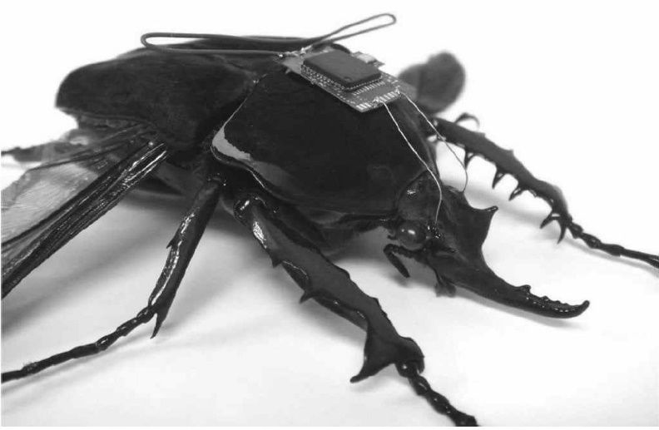 Darpa Hydrogel (reference) is an artificial substance that creates a converter between the electromagnetic signal and living cell, tissue and organ. Converts an electromagnetic signal from a transmitter to a signal which a living cell understands and responds to. (see photo of beetle – Darpa Hydrogel was injected into these nerve structures and was controllable via a radio).

Darpa Hydrogel and lithium block and destroy the pineal gland and cause the thinking person to become a controllable biorobot. A hydrogel is a carrier of an active substance, its task is to get the substance into the body at a pre-desired place.

Briefly on the issue of vaccines. Vaccines contain Darpa Hydrogel, lithium and patented genetic information. mRNA is not an untested novelty. In breeding and for top athletes, this type has been used for doping for many years. For top athletes 4), this doping significantly shortens their life. Genetic information in the vaccine leads to the creation of a patented mutant. The dream of the dark forces around Bill Gates is to achieve to force these mutants, for example by vaccination, to regularly upgrade as a computer program.

P.S.:

Darpa Hydrogel hollow nylon fibres fill the FFP2 class plastic respirators. This Darpa Hydrogel with additives is slowly released from the respirators. When breathing, it enters the human airways.

The swabs used for PCR are also composed of hollow nylon fibres with Darpa Hydrogel.

DARPA: <https://www.darpa.mil/>

The Defense Advanced Research Projects Agency is a research and development agency of the United States Department of Defense responsible for the development of emerging technologies for use by the military. Originally known as the Advanced Research Projects Agency, the agency was created on February 7, 1958 by President Dwight D. Eisenhour, USA

LINKS

1. https://www.copan.com
2. https://www.darpa.mil/work-with-us/covid-19 LINKS  
   https://www.forbes.com/sites/forbestechcouncil/2020/05/18/technology-in-a-time-of-crisishow-darpa-and-ai-areshaping-the-future /? sh = 47041f384e47 https://www.nature.com/articles/s41598-019-48874-y http://techfinder.stanford.edu/technologies/S18-354_nanoparticle-hydrogels-for  
   https://finance.yahoo.com/news/7-ambitious-darpa-projects-help-225243090.html https://www.inverse.com/article/22675-darpa-cyborg-insects

https://www.forbes.com/sites/kelseyatherton/2020/08/25/locust-bomb-sniffers-just-the-latestmilitary-insectcyborg/?sh = 77fd6e153efa https://journalbipolardisorders.springeropen.com/articles/10.1186/s40345-020-00191-4 https://www.thelancet.com/journals/lanpsy/article/PIIS2215-0366(20)30564-2/fulltext https://www.ncbi.nlm.nih.gov/pmc/articles/PMC7307055/

3) https://www.fmed.uniba.sk/fileadmin/lf/sluzby/akademicka_kniznica/PDF/Elektronicke_knihy_LF_UK/O chorenia_endokrinneho_systemu.pdf https://link.springer.com/chapter/10.1007/978-1-4612-3524-8_27

https://www.semanticscholar.org/paper/PINEAL-RESPONSE-TO-LITHIUM1-DeviRao/b7238dc6e7574492ca62a44b13b36fac4ce7f76b

1. https://www.antidoping.sk/data/files/511_zoznam-zakazanych-latok-2020.pdf   
   https://tech.sme.sk/c/4289532/kobylky-ficia-na-droge-stastia.html

**OTHER MATERIALS CONFIRMING THE DISCOVERIES OF THE SLOVAK LABORATORY**

In this video, various scientists share about the detailed visual and spectral analysis of the PCR tests. Such elements as zircon, aluminium, titanium and silver nanoparticles were found, which is completely inexplicable in this type of test. The structure of the swabs, which allow them to play the role of a delivering system has been confirmed 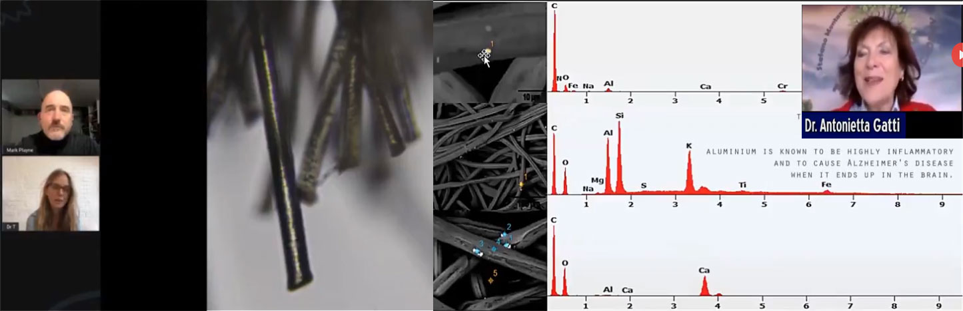[Swab science: invasion & destruction](https://www.bitchute.com/video/uW6b2qAyjica/) ;  
[PCR Swab Spikes - Poison delivery system](https://www.bitchute.com/video/BPb5f42mdFMD/)

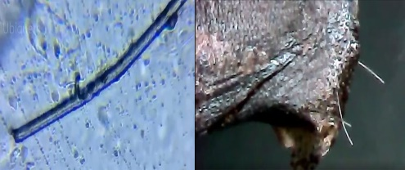Video showing a photo of a fibre from a PCR test, which confirms that these fibres are hollow and can carry content. The video also shows fibres from a PCR test stuck to the skin of a fish, ie. demonstration that they are designed to break off and remain in the skin (mucosa). [PCR Test Swab Look INSIDE the Swab](https://www.bitchute.com/video/xEdJKhUzDJcs/)

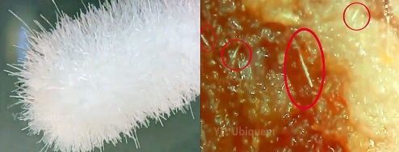In this video, a comparison is made between a cotton swab and a PCR test. As seen on the video, when the cotton swab is rubbed on a piece of meat nothing remains on the surface of the meat. In contrast, when the PCR test swab is applied on the surface of the meat immediately some fibres pierce the top layer of the meat and they stick inside the meat. [COVID Test Swab](https://www.bitchute.com/video/Yjpim5ubGhLZ/)

**ATTACHMENT 5 THE MASS MURDER THROUGH GRAPHENE OXIDE IS POSSIBLE**Graphene oxide responds actively to 5G and other frequencies. When inside the body it can cause instant damage to the heart, brain and nervous system causing injury and death.

Some videos showing how graphene oxide can react when exposed to a certain environment and frequencies:

|  |  |  |  |
| --- | --- | --- | --- |
| [NANOTUBES SELF-ASSEMBLY  TECHNOLOGY](https://www.bitchute.com/video/1maruJm8petu/) | [GRAPHENE OXIDE ACTIVATED BY CELL PHONE EMF FREQUENCY RADIATION](https://www.bitchute.com/video/KYhM255LALhM/) | [GRAPHENE OXIDE REACTION TO FREQUENCIES](https://www.bitchute.com/video/CeA6IHf8YrNA/) | [GRAPHENE OXIDE AND A MAGNET](https://www.bitchute.com/video/FvGYAoUDBNoR/) |

[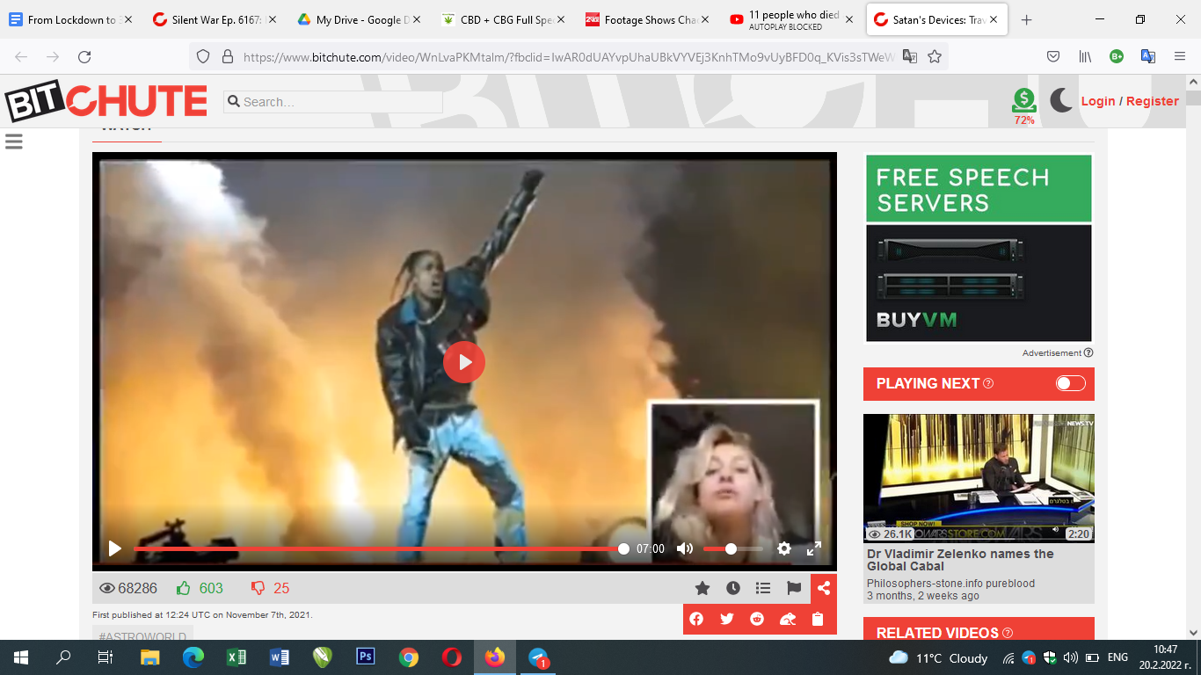](https://www.bitchute.com/video/WnLvaPKMtalm/)  
**MASS MURDER AT A CONCERT**  
In this video a doveted to Travis Scott fan who followed him before he even became famous describes the absolute horror she experienced at his fatal concert at Travis Scott Astroworld music festival in Houston in November 2021. According to her, the media was absolutely lying about the real number of casualties, which they announced to be 8. She said she saw **HUNDREDS** of bodies laying around and other people saw that as well. All the people were suffocating and she saw people having blue lips (graphene oxide can cause suffocation and the reactions described). After this experience from hell she’s done once and for all with her favourite star.   
Satan's Devices: Travis Scott Astroworld Satanic Ritual: 5G in action ?  
<https://www.bitchute.com/video/WnLvaPKMtalm/>

Houston fire chief Samuel Peña told reporters: “People **began to fall out**, **become unconscious**, and it created additional panic… He added that it triggered a “mass casualty” event, with 17 people taken to hospitals and **11 cardiac arrests**.” There’s something quite unusual and untypical about this event as people in concerts do not “fall out”, “become unconscious” and especially have “cardiac arrests”. Young people definitely don’t have cardiac arrests on concerts. All these elements are produced by something else and it’s most probably the graphene oxide injected in the bodies through the mRNA jabs which was activated by 5G or certain frequencies from the sound and light equipment. In order to be on this concert you had to show a proof that you have been fully vaccinated or show a negative COVID test. <https://www.2oceansvibe.com/2021/11/08/footage-shows-chaos-at-travis-scott-concert-where-eight-people-died-as-performer-also-releases-video/>

[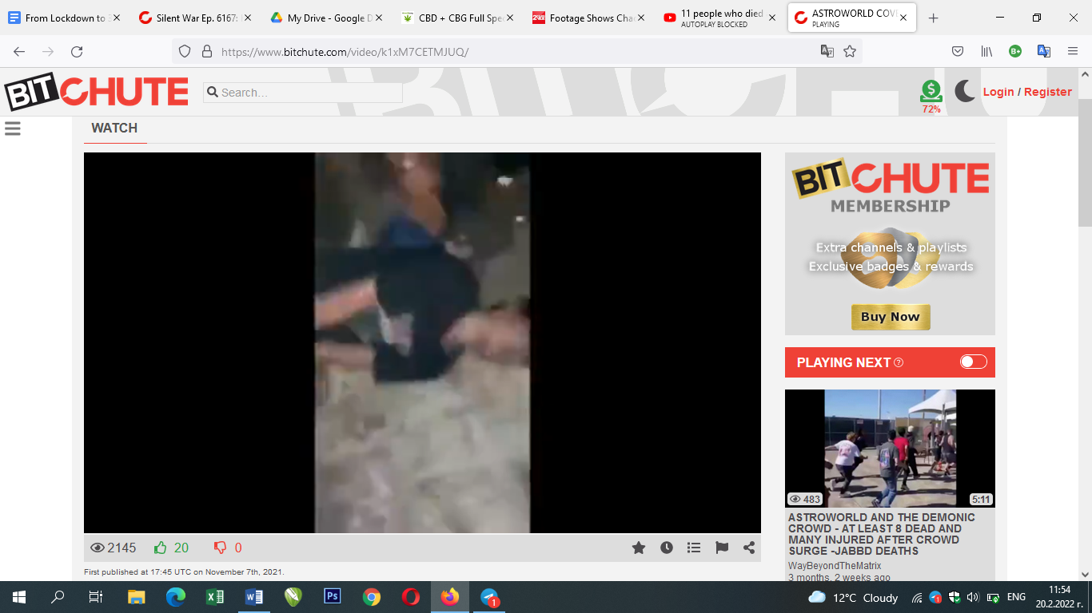](https://www.bitchute.com/video/k1xM7CETMJUQ/)In this detailed analysis of the event and the factors that are possible to have caused the massive amounts of heart arrests one can see a video from the audience where a young man lays on the ground and has convulsions. There’s plenty of space around him and no crowd trampling and crushing as reported by the fake media. This kind of reaction can hardly be ever seen from a drug but the graphene oxide can cause it when activated with the right frequency. As witnessed by visitors of the event there were hundreds of people with serious suffocations and going unconscious. <https://www.bitchute.com/video/k1xM7CETMJUQ/>

**[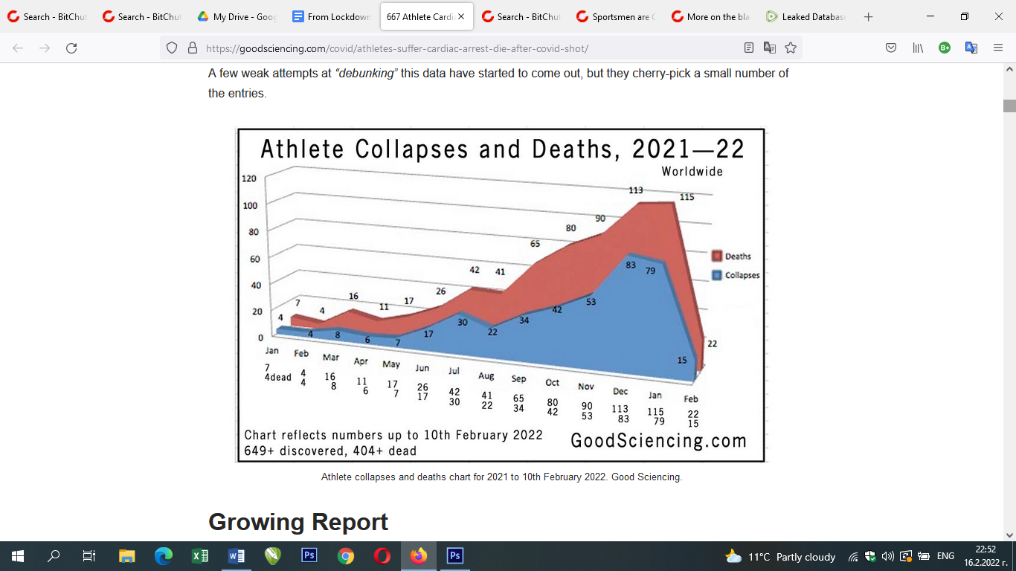](https://goodsciencing.com/covid/athletes-suffer-cardiac-arrest-die-after-covid-shot/)ATTACHMENT 6**GENOCIDE. UNEXPLAINED COLLAPSES AND DEATH IN FRONT OF THE EYES OF MILLIONS. NO ONE MAKES THE CONNECTION WITH THE VACCINES EXCEPT THE "CONSPIRACY THEORISTS"

This graph displays the unexplained growth of collapses and deaths among the healthiest part of the population, the athletes, in the period 2021-22 (just after vaccinations). **Real Science publication:** [*667 Athlete Cardiac Arrests, Serious Issues, 414 Dead, After COVID Shot*](https://goodsciencing.com/covid/athletes-suffer-cardiac-arrest-die-after-covid-shot/)

*[](https://thelibertydaily.com/buried-bombshell-tennis-world-rocked-as-fifteen-fully-vaccinated-players-unable-to-finish-miami-open/)*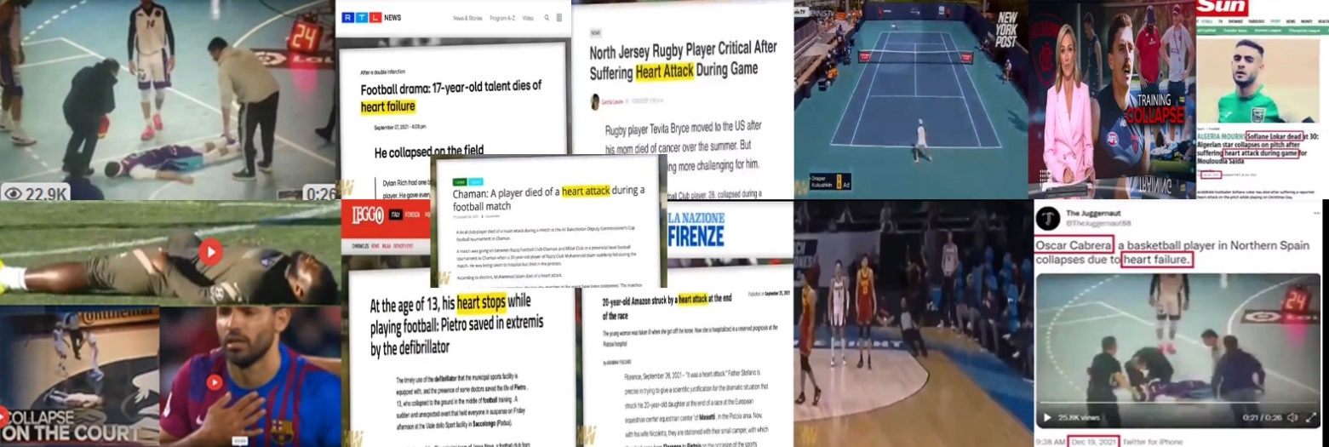Video compilation with athletes from around the world who collapse, have heart attacks or die. Such cases are becoming more common on the screens. **Bitchute.com:** [**Sportsmen are Collapsing Around The World - Why?**](https://www.bitchute.com/video/wLsRQMIYEQKI/)

[**Tennis World Rocked as FIFTEEN “Fully Vaccinated” Players Unable to Finish Miami Open / Apr. 2, 2022**](https://thelibertydaily.com/buried-bombshell-tennis-world-rocked-as-fifteen-fully-vaccinated-players-unable-to-finish-miami-open/)

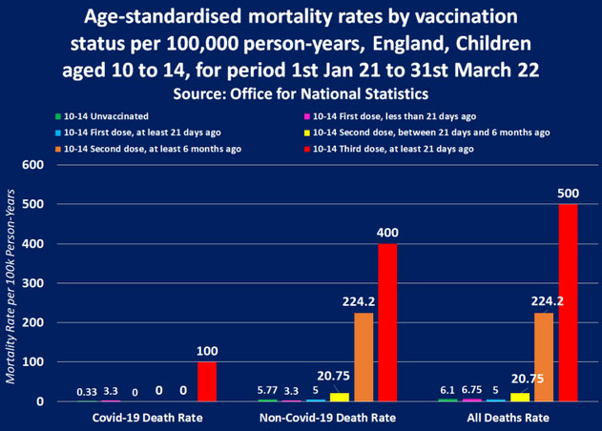

**Vaccinated Children are shocking 30,200% more likely to die than Unvaccinated Children.**UK Gov. admits COVID Vaccine is killing Kids after publishing official report from the Office for National Statistics

[**https://expose-news.com/2022/07/08/ukgov-admits-covid-vaccine-killing-kids/**](https://expose-news.com/2022/07/08/ukgov-admits-covid-vaccine-killing-kids/)

**Data from the Defense Health Agencies Defense Medical Epidemiology Database (DMED**) shows skyrocketing levels of disease among military personnel in the US army.

**[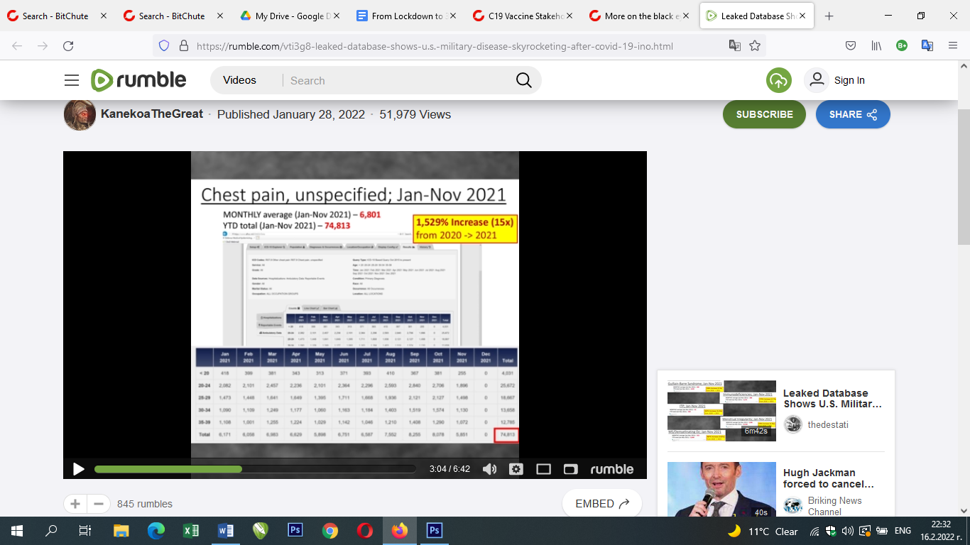](https://rumble.com/vti3g8-leaked-database-shows-u.s.-military-disease-skyrocketing-after-covid-19-ino.html)**Percentage Increase Over the Average of the Last Five Years

* **H**eart Attacks **269%**
* Pericarditis **175%**
* Myocarditis **285%**
* Pulmonary Embolisms **467%**
* Cerebral Infarction **393%**
* Bell's Palsy **319%**
* Guillain-Barre **250%**
* Immunodeficiencies **275%**
* Menstrual Irregularity **476%**
* Multiple Sclerosis **487%**
* Miscarriage **306%**
* HIV **590%**
* Chest Pain **1,529%**
* Labored Breathing **905%**

Video: <https://rumble.com/vti3g8-leaked-database-shows-u.s.-military-disease-skyrocketing-after-covid-19-ino.html>

Article: <https://www.georgiarecord.com/military-med-skyrocketing-disease-data-leaked-biden-regime-knowingly-continues-destruction-of-force/>

**[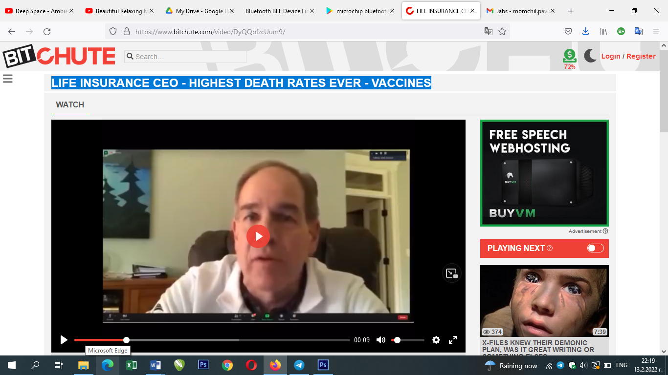](https://www.bitchute.com/video/DyQQbfzcUum9/)5000 % INCREASE IN MORTALITY THIS YEAR**  
In this video the CEO of one of the largest life insurance companies explains why the COVID vaccine deaths are **the most major catastrophic event for the last 200 years.**   
**Bitchute.com:** [LIFE INSURANCE CEO - HIGHEST DEATH RATES EVER](https://www.bitchute.com/video/DyQQbfzcUum9/). and why this year they expect [5000% increase in morbidity rate due to Covid injection induced AIDS](https://www.bitchute.com/video/BsnGfVcNcR8p/)

**EMBALMER REVEALS 93% OF CASES HAVE DEADLY CLOTS CAUSED BY THE COVID VAX**

[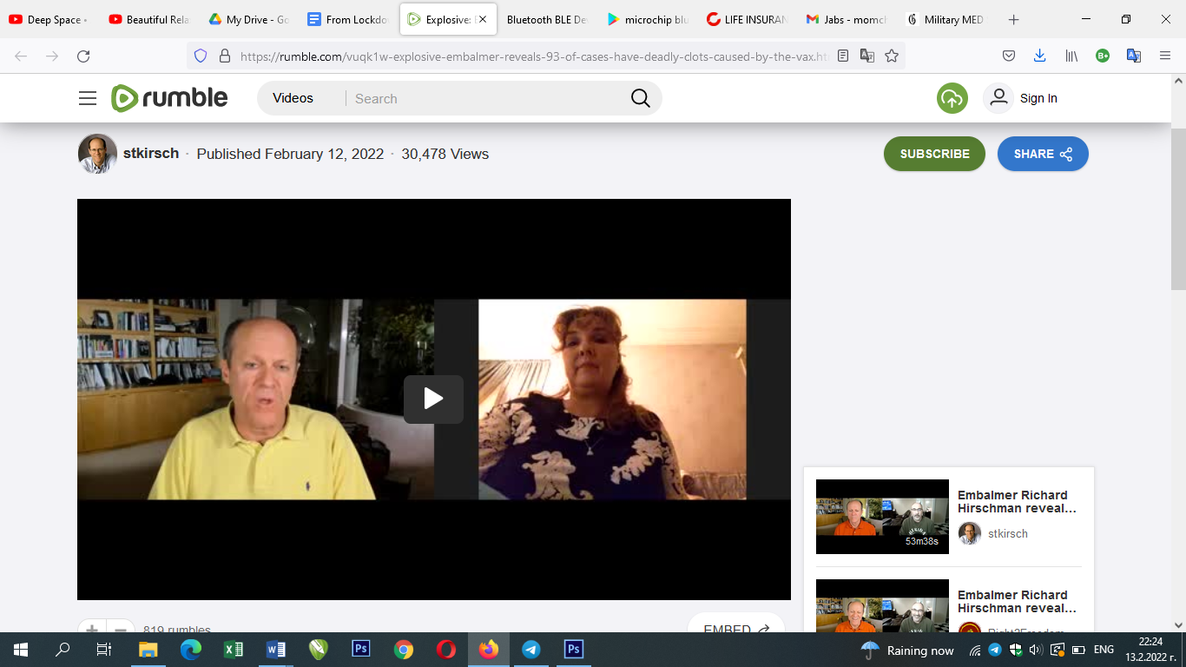](https://rumble.com/vuqk1w-explosive-embalmer-reveals-93-of-cases-have-deadly-clots-caused-by-the-vax.html) Anna Foster is an embalmer with 11 years of experience in Carrollton, MO. The big news is that she found the unusual clots in 93% of the last 30 people who she embalmed. The clots are only associated with people who have been vaccinated. They were only observed after the vaccines rolled out. Watch the full video [HERE](https://rumble.com/vuqk1w-explosive-embalmer-reveals-93-of-cases-have-deadly-clots-caused-by-the-vax.html).

[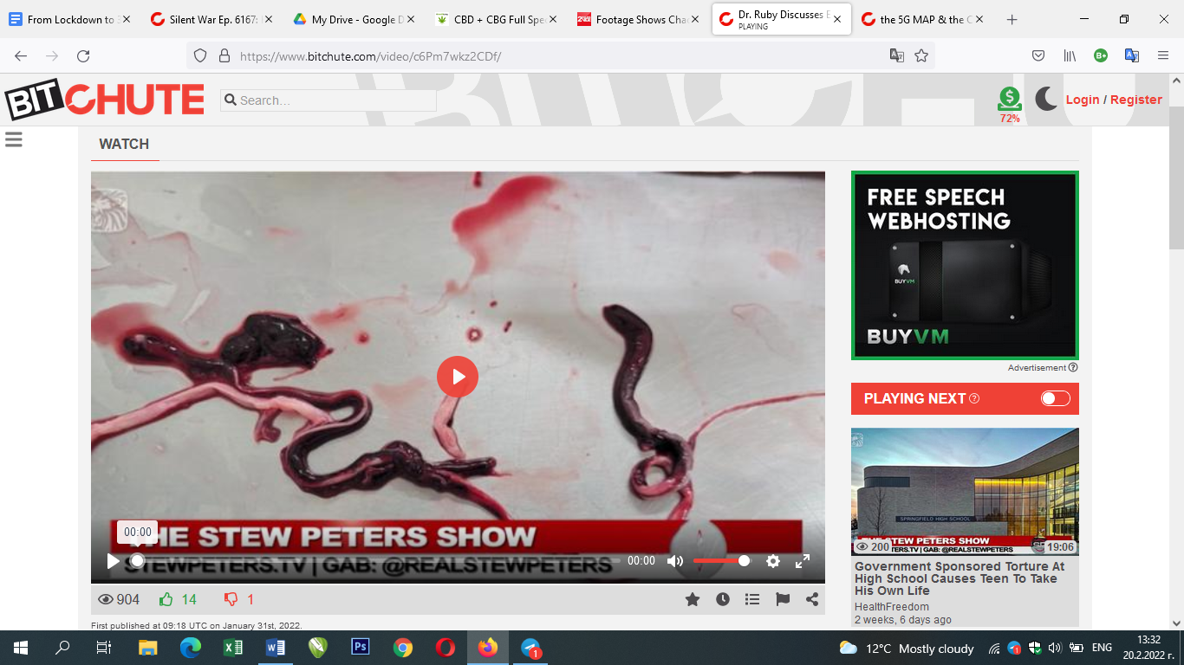](https://www.bitchute.com/video/c6Pm7wkz2CDf/)Richard Hirschman has been an embalmer for over 20 years. In 2021, he started noticing very odd blood clots that he had never seen before – extraordinarily long and extremely hard to break down. In Jan 2022, 65% of his cases exhibited these clots. The only rational conclusion is that the clots, which are deadly, are all associated with the COVID vaccines.   
Watch here [a short presentation on the Stew Peters Show](https://www.bitchute.com/video/c6Pm7wkz2CDf/)   
or a [one hour interview here](https://www.bitchute.com/video/Iu1HTPuj46vb/).

**[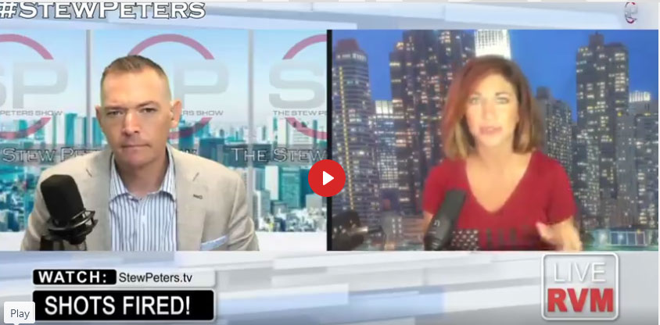](https://www.bitchute.com/video/PxgR7Cfn8Kmd/)MISCARRIAGE AFTER VACCINATION IS 82%**The New England journal of medicine: [*Preliminary Findings of mRNA Covid-19 Vaccine Safety in Pregnant Persons*](https://www.nejm.org/doi/full/10.1056/NEJMoa2104983)***Source: Bitchute -*** [***FACT- 82% OF PREGNANT WOMEN IN STUDY HAD MISCARRIAGE***](https://www.bitchute.com/video/PxgR7Cfn8Kmd/)Pfizer trial documents reveal attempts to cover up the death of 100% of unborn babies in outcomes actually reported**.** [**Pfizer trials: All injected mothers lost their unborn babies**](https://drtrozzi.org/2022/01/19/pfizer-trials-all-injected-mothers-lost-their-unborn-babies/)

[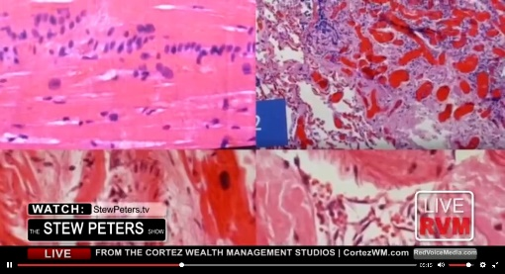](https://www.bitchute.com/video/cMIGuBloOfBz/)**[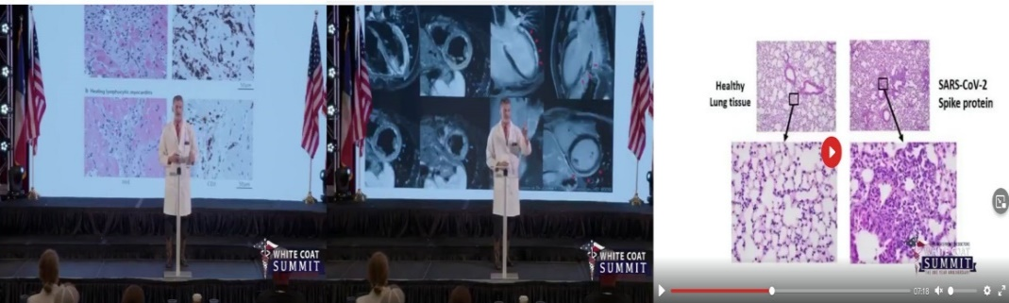](https://www.bitchute.com/video/RZYzPyfYH5EX/)**[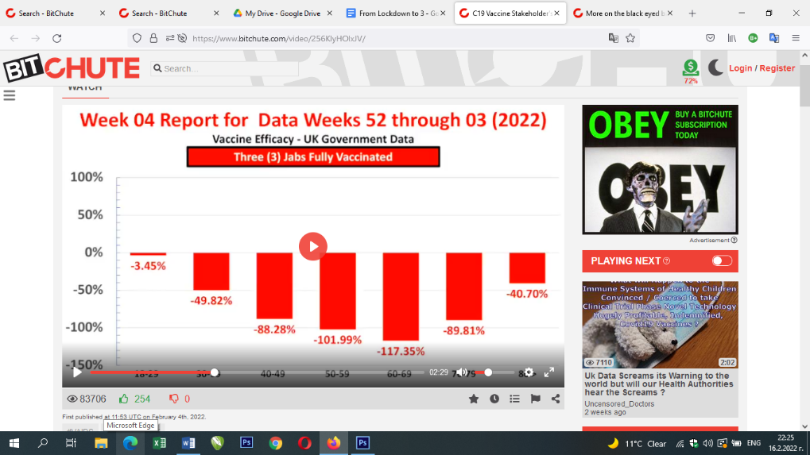](https://www.bitchute.com/video/256KlyHOlxJV/)**THE OFFICE FOR NATIONAL STATISTICS IN UK CONFIRMS** [**70K PEOPLE HAVE DIED WITHIN 28 DAYS OF COVID-19 VACCINATION IN ENGLAND & 179K HAVE DIED WITHIN 60 DAYS**](https://expose-news.com/2022/05/19/70k-dead-28-days-covid-vaccination/) **THE UK GOVERNMENT ADMITS THAT** [**VACCINES HAVE DAMAGED THE NATURAL IMMUNE SYSTEM OF THOSE WHO HAVE BEEN DOUBLE-VACCINATED**](https://assets.publishing.service.gov.uk/government/uploads/system/uploads/attachment_data/file/1027511/Vaccine-surveillance-report-week-42.pdf)The UK government has admitted that once you have been double-vaccinated, you will never again be able to acquire full natural immunity to Covid variants - or possibly any other virus. In its Week 42 "COVID-19 Vaccine Surveillance Report", the UK Department of Health admits on page 23 that **"N antibody levels appear to be lower in people who become infected after two doses of vaccination". It goes on to say that this drop in antibodies is essentially permanent.** What does this mean? We know that vaccines do not prevent infection or transmission of the virus (indeed, the report elsewhere shows that vaccinated adults are now much more likely to be infected than unvaccinated ones). The British now find that the vaccine interferes with the body's ability to make antibodies after infection not only against the spike protein but also against other parts of the virus. In particular, vaccinated people do not appear to form antibodies against the nucleocapsid protein, the envelope of the virus, which is a crucial part of the response in unvaccinated people. **In the long term, the vaccinated are far more susceptible to any mutations in the spike protein, even if they have already been infected and cured once or more.** The unvaccinated, on the other hand, will gain lasting, if not permanent, immunity to all strains of the alleged virus after being naturally infected with it even once. [SOURCE](https://assets.publishing.service.gov.uk/government/uploads/system/uploads/attachment_data/file/1027511/Vaccine-surveillance-report-week-42.pdf) **FIRST AUTOPSIES OF VACCINATED WITH ALARMING FINDINGS**All inner organs infected from the spike proteins. Damage seems to be irreversible. **Source: Bitchute -** [**Autopsy Results of the VAXXED - Dr Ryan Cole**](https://www.bitchute.com/video/RZYzPyfYH5EX/)  
  
**MORE AUTOPSIES WITH DEVASTATING JAB EFFECTS**A detailed presentation from the result of 8 autopsies of vaccinated people who died within 2 weeks from their vaccination reveals how the white blood cells and the T-cells are trying to defend the organism from foreign particles in the vaccines. On another slide we see an unusually enlarged lymph node. The pathologists are adamant that they have never encountered anything like this in their whole practice. [SOURCE](https://www.bitchute.com/video/cMIGuBloOfBz/)

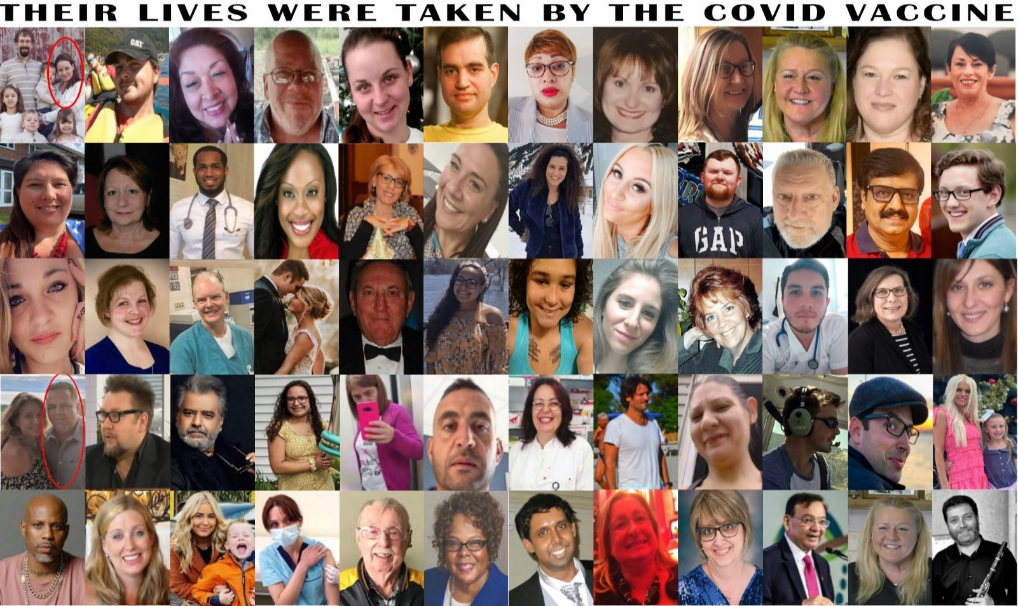GENOCIDE. THE NUMBER OF COVID VACCINES DEATHS IS HIGHER THAN THE VACCINES DEATHS OF ALL OTHER VACCINES TAKEN TOGETHER FOR THE LAST 30 YEARS

The pictures above are taken from [https://thecovidblog.com](https://thecovidblog.com/category/vaccine-deaths/) and <http://tiny.cc/mRNA-vax-cases> . You can visit also <https://www.covidvaccinevictims.com/> as well as Telegram groups for real life stories: <https://t.me/covid_vaccine_injuries> , <https://t.me/cv19vaccine_reactions> , <https://t.me/covidvaccinevictims> a.o.

[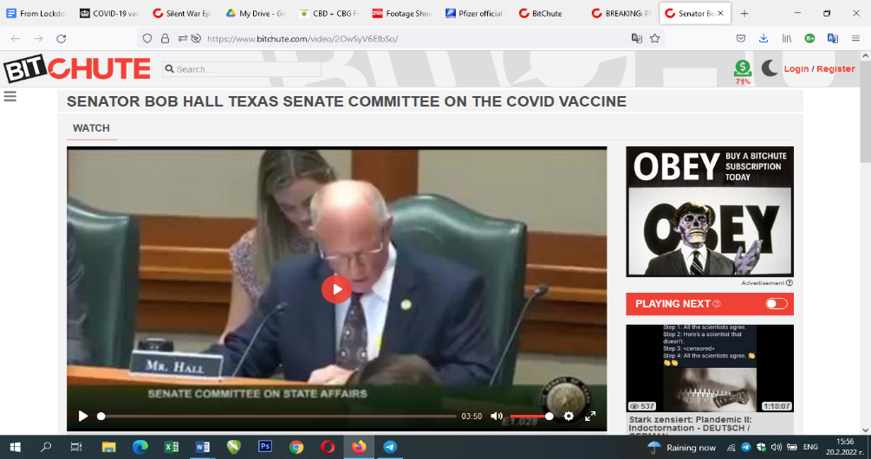](https://www.bitchute.com/video/2OwSyV6EfbSo/)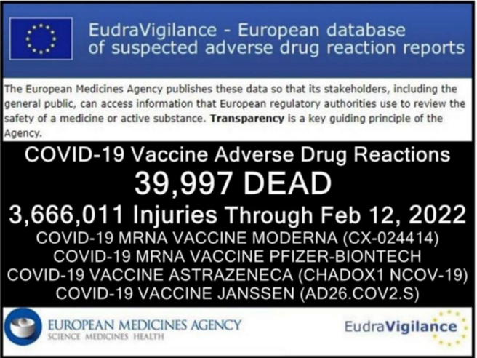 According to the official data base of the European Union by the 12th of February 2022 in Europe:  
**39,997 people were killed and  
3,666,011 people were injured** by the vaccines.But these **NUMBERS REPRESENT LESS THAN 1% OF THE REAL CASES IN LIFE**!  
The following two videos explain about the numerous studies done in the last 3 decades on the system of collecting the data for the adverse effects from the vaccines and **in all cases** it turned out that this data represents less than 1% of the real numbers: ***Bitchute.com****,* [*EVIDENCE VACCINE SAFETY SYSTEM IS FAILING*](https://www.bitchute.com/video/zJLGwYoxpfQe) *, The Highwire with Del Bigtree.* ***Bitchute.com****,* [*Adverse Events Testimony to Texas Senate: Dr. Ben Edwards*](https://www.bitchute.com/video/s5FMSd5Elem8/)**THIS SHOULD STOP** Senator Bob Hall in front of the Texas Senate Committee, May 2021: “In 2019 there were reported to the VAERS 203 vaccine deaths, in 2018 – 119, in 2007 – 85. From December 2020 through April 23 2021 (4 months), there were reported 3,362 deaths from COVID vaccines. That’s roughly 30 people a day. VAERS is being estimated to report less than 1% of what actually happens… In 1976 nearly 45 million people were vaccinated for the swine flu and only 53 died… but THE PROGRAMME WAS IMMEDIATELY HALTED, BECAUSE IT WAS CONSIDERED TOO RISKY! 53 DEATHS!.. and we are approaching 4000 with the COVID!” BITCHUTE.COM, [*Senator Bob Hall Texas Senate Committee on the Covid Vaccine*](https://www.bitchute.com/video/2OwSyV6EfbSo/)

**ATTACHMENT 7**

**GRAPHENE OXIDE - A BIO-WEAPON FOR DEPOPULATION AND CONNECTING PEOPLE WITH THE INTERNET IS BEING DISTRIBUTED IN THE ENVIRONMENT**

[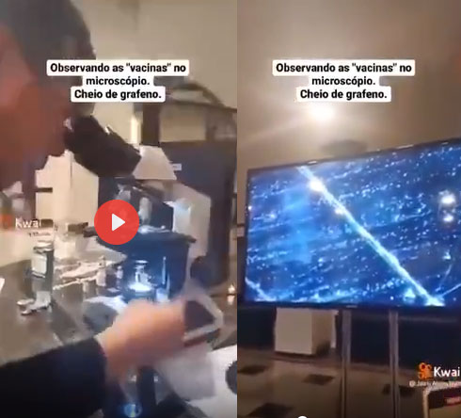](https://www.bitchute.com/video/ycS5h00G5VHq/)Graphene oxide intoxication, the element through which the human nervous system connects to the Internet of Things, occurs in all sorts of ways - through vaccines (all kinds of vaccines), food, drugs, cosmetics, air and water..

* Influenza vaccines
  + Graphene oxide in influenza vaccines - microscopic images:  
    [https://www.facebook.com  
    /SriNithyaUttarananda/posts/2521693377975211](https://www.facebook.com/SriNithyaUttarananda/posts/2521693377975211)
  + Graphene oxide is officially included in influenza vaccines:  
    <https://www.bitchute.com/video/AL3vB4e5rClR/>

[Public demonstration in Brazil of observing graphene oxide in Pfizer’s vaccine](https://www.bitchute.com/video/ycS5h00G5VHq/)

* VAERS database: 84,330 deaths from influenza vaccine in 2021 compared to 108 in 2018 (could there have been graphene oxide?)  
  <https://www.bitchute.com/video/3YGlis7UB8Tn/>
* Magnetized drugs (graphene oxide)  
  [https://www.facebook.com/groups/655914051777757  
  /permalink/838266350209192/](https://www.facebook.com/groups/655914051777757/permalink/838266350209192/) ;  
  [Particles attracted to a strong magnet in UK Prescribed drug Flucloxacillin antibiotic](https://www.bitchute.com/video/YW9BbrIOy9LU/)
* Magnetized meat (graphene oxide)  
  <https://www.bitchute.com/video/AfY7gqWbBAot/>
* Magnetized cereals (graphene oxide)  
  <https://www.bitchute.com/video/7zw5zsGBcni6/>
* Magnetized chocolates (graphene oxide)

<https://www.bitchute.com/video/JbQsqlEi1ufk/>

* Magnetic tea (graphene oxide)  
  <https://www.bitchute.com/video/JYaYBaaz96DK/>
* Graphene oxide in vaccines, PCR tests, masks and foods

<https://odysee.com/@laquintacolumna:8/URGENTCOMMUNICATIONFROMTHEFIFTHCOLUMN-ACTIONINFOGRAPHIC:8>

* Graphene oxide found on beaches  
  <https://www.bitchute.com/video/WETa2WQuzqVz/>
* Magnetization of graphene oxide is everywhere: water, food, air, drugs and "vaccines"  
  <https://www.bitchute.com/video/oNtl7GyyiRJn/>
* A plan to spray global food supplies with magnetic nanoparticles has been announced  
  <https://www.bitchute.com/video/BHKAnftV3uIU/>

**ATTACHMENT 8**

**DANGERS OF 5G**

Why the need for a section on 5G in this document? We need to understand that 5G in the field of telecommunications is the same as the Covid19 vaccines are in the field of medicine. Both have nothing to do with the improvement of life and everything to do with the complete destruction of the health of the people in a hidden way. All of this is seen quite well from the documents provided below and legal actions against 5G are already under way, yet there is no time left when it comes to the vaccinated where dangers come in two ways.

* **RADIATION AND INTERACTION OF 5G WITH THE GRAPHENE OXIDE INSIDE THE BODIES OF THE VACCINATED**5G all by itself is a highly dangerous factor in the environment, but when 5G radiation is added to the 24/7 Bluetooth radiation emitted by the bodies of the vaccinated this leaves them with even much lower chances of staying healthy and safe compared to the non-vaccinated. Further, we are not aware of all potential risks of the interaction of 5G with the graphene oxide. Could there be any variations of the signals that might prove dangerous in interacting with the graphene oxide inside the vaccinated?   
  Also, there already has been a mass casualty event where a large number of people died at a concert and the police reports and the stories of the witnesses point to the possibility of 5G or other equipment interacting with the graphene oxide inside the bodies of the vaccinated (see **ATTACHMENT 5 THE MASS MURDER THROUGH GRAPHENE OXIDE IS POSSIBLE**). One more source: [The Vaxx, 5G and Smartphones Are Inextricably Linked](https://zedie.wordpress.com/2022/03/18/the-vaxx-5g-and-smart-phones-are-inextricably-linked/)
* **POSSIBILITY OF MASS MANIPULATION WITH THE PURPOSE OF CREATING SOCIAL DISORDER ON A LARGE SCALE**Vaccinated people emit Bluetooth signals which allow for two way communication: download and upload of information. As the graphene oxide connects directly with the whole nervous system of the body, including the brain itself, this allows for direct influence through the telecommunication systems. If there is 5G coverage in the area this allows for high speed full spectrum control over the body/mind/emotions of the vaccinated. What could be the consequences from this?

[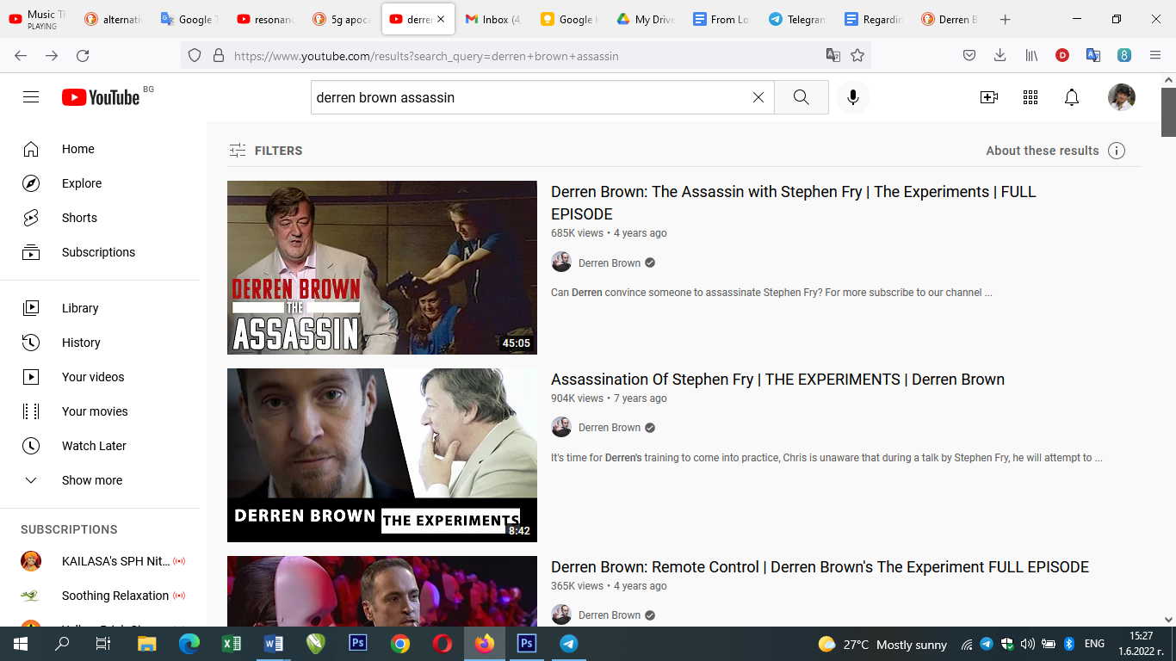](https://www.youtube.com/watch?v=owootTAuxic)In his experiment, “[The Assassin](https://www.youtube.com/watch?v=owootTAuxic)”, the famous British mentalist and illusionist Derren Brown demonstrates how it is possible to program somebody to kill without them realising it. This is how he proved that the “conspiracy theory” that the CIA hypnotised unsuspecting candidates in its’ secret program, MK-Ultra, to carry out assassinations in the 50s and 60s might actually be true. In another episode, “[The Heist](https://www.youtube.com/watch?v=HDtMMsFoHuY&t=18s)”, he once again demonstrates how he can manipulate a completely unsuspecting participant from his motivational seminar to steal £100,000 in what he believes is a genuine armed robbery.   
  
Project MK-Ultra was said to last from 1953 until about 1973. Details of the illicit program didn’t become public until 1975 during a congressional investigation into widespread illegal CIA activities within the United States and around the world. Some people claim this program was never stopped. In this article, <https://www.governmentpropaganda.net/mk-ultra-and-mass-murderers/>, the connection of this program with mass-murder is investigated. There are some materials on the internet connecting this program to the school shootings in the USA: [The True Evil Behind America's Mass School Shootings](https://www.bitchute.com/video/BUPWldoNyu4f/). Prior to 1999, school shootings were practically nonexistent. But today, they have become almost predictable, so much so that an ominous pattern can be found. And this pattern is now being used to curtail the Second Amendment.  
  
Having this information at hand we can see the incredible potential that 5G gives in the hands of the people with the wrong intentions to direct the actions of large numbers of vaccinated people in a direction of creating social disorder that suits the political interests of this group. Therefore, the immediate halt of 5G is of highest priority.

**FURTHER DANGERS OF 5G**

[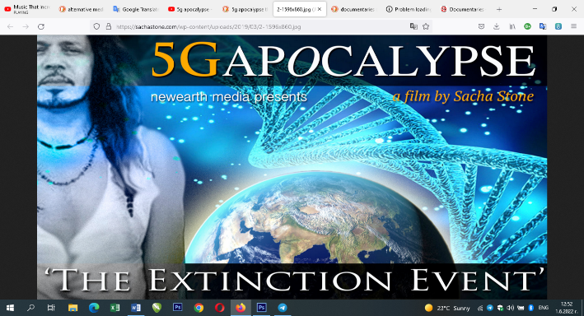](https://www.youtube.com/watch?v=EKhG9seiAlU)Over 180 scientists and doctors are warning of serious 5G dangers and health risks. [This document](https://ehtrust.org/wp-content/uploads/Scientist-5G-appeal-2017.pdf) summarises the scientists’ views and links to over 20+ research journals.

“We, the undersigned scientists, recommend a moratorium on the roll-out of the fifth generation, 5G, until potential hazards for human health and the environment have been fully investigated by scientists independent from industry. 5G will substantially increase exposure to radio frequency electromagnetic fields (RF-EMF)… and has been proven to be harmful for humans and the environment.”

[**5G APOCALYPSE THE EXTINCTION EVENT**](https://www.youtube.com/watch?v=EKhG9seiAlU)The most popular documentary on the dangers of 5G. A must watch.

The scientists who signed this appeal arguably constitute the majority of experts on the effects of non-ionizing radiation. They have [published more than 2,000 papers](https://blogs.scientificamerican.com/observations/we-have-no-reason-to-believe-5g-is-safe/) and letters on EMF in professional journals.

The following videos reveal a complete coincidence of the maps of spreading of the Covid19 cases and the roll-out map for 5G. **5G MAP = COVID MAP. COULD BE THE RADIATION, NOT THE VIRUS.**

|  |  |
| --- | --- |
| [5G MAP OF THE WORLD](https://www.bitchute.com/video/nuPlVxrSmT5j/) = COVID MAP | [THE 5G MAP & THE COVID-19 ENVIRONMENTAL THEORY](https://www.bitchute.com/video/4XZyM63fcK5K/) |

[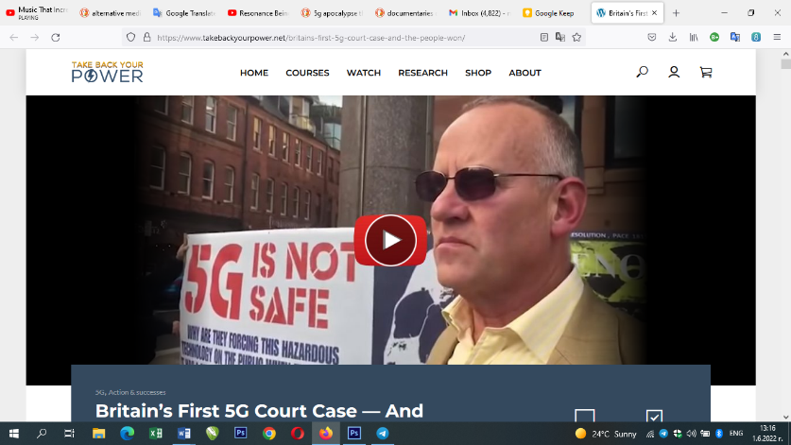**Britain’s First 5G Court Case — And The People Won**](https://www.takebackyourpower.net/britains-first-5g-court-case-and-the-people-won/)After a city council attempted a silencing campaign, a UK judge has declared that the people have a right to know about the harmful effects of 5G millimetre-wave technology being deployed upon them.

[Former Radiologist speaks on 'Radiation Stress' aka Microwave Sickness vs Cov!d Symptoms](https://www.bitchute.com/video/HORlxvXVC2oH/) . She says that all her patients during the peak of the Covid pandemic in February-March 2020 were off the charts when measured for radiation stress as if it was some kind of Chernobyl event.

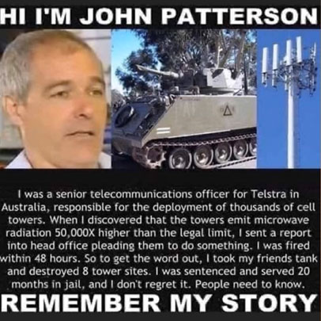[**Telecom Worker Destroys Cell Towers**](https://citizensfor5gawareness.org/2019/12/30/telecom-worker-destroy-cell-towers/). What inconvenient truth led a highly-regarded radiation expert to take the law into his own hands and demolish six mobile phone stations? This material is another demonstration of how the telecommunication authorities ignore the signals regarding the health and safety of the implemented technology for wireless communication. This material is from 2010 and the same attitude of the authorities continues with 5G.

**Quite disturbing videos of real live measurements of dangerously high levels of radiation from 5G in big cities like London and Sydney already appeared on the internet!**1. [EMR levels in London](https://www.bitchute.com/video/JvzTa0OvATRO/) / 2. [5G tower radiation measured!](https://www.youtube.com/watch?v=4ukbsefPl4o)  / 3. [Is 5G Safe? | Sydney's Smart Cell Lamp Posts](https://www.youtube.com/watch?v=_VDLTVKhaxU)

Further useful information:

**Legal Actions on 5G in UK**

* **Glastonbury calls for 5G inquiry and brings the matter to the attention of MP’s, The Government, Public Health England and The International Commission on Non-Ionizing Radiation Protection**

“*The Town Council is greatly indebted to the members of the 5G Advisory Committee, who have met regularly; collected and studied a large volume of literature – and received presentations from a number of academics and professionals, including the Director of Mobile UK, the organisation overseeing the roll-out of 5G in the UK.  
As chair of the advisory committee, I have been impressed by the number of councils and local authorities who have been in contact; requesting copies of the committee’s report and recommendations…  However, I must stress that a Town Council, such as Glastonbury, has absolutely no power to stop the roll-out of 5G, which is why it is so important to bring our report to the attention of MPs, the Government, Public Health England, and the International Commission on Non-Ionizing Radiation Protection.*”  
Cllr. Jon Cousins, Deputy Mayor of Glastonbury, and Chair of the 5G Advisory Committee.[https://glastonbury.gov.uk/2020/04/29/glastonbury-calls-for-5g-inquiry/?fbclid=IwAR2A9i5xt2wTvCkRacKoypbkQCxmKTtZ924SBlnjilimrvWAfKvhUzNwOfk](https://glastonbury.gov.uk/2020/04/29/glastonbury-calls-for-5g-inquiry/?fbclid=IwAR267Bcv5B0x9r6POoIMGwbGoPt30-5msS0-CRoQnoWQGi240dUU9qWy1cA)

* **Legal Action Against the UK Government regarding 5G**   
  <https://actionagainst5g.org/> is the website dedicated to the case to be filed in the UK against the implementation of the 5G technology in the country. It will be headed by the legendary human rights fighter, Michael Mansfield QC, who will challenge the UK government over its failure to take notice of the health risks and public concerns related to 5G.

**Useful links:**  
Documentaries on 5G

* [**The Truth Behind 5G**](https://www.youtube.com/watch?v=E0fa1TwPoMk)
* [**Five G - (2019 Documentary)**](https://www.youtube.com/watch?v=bG8f5kUpbcg)
* [**The 5G trojan horse**](https://theconsciousresistance.com/trojanhorse/?fbclid=IwAR1zsziqfZ9uuElnU3ITUhd4TJFxG5DKLgbzxORHhZcl9PjQWSFQAJzzccM)
* [**The 5G Dragnet**](https://www.corbettreport.com/the-5g-dragnet/)
* [**Arthur Firstenberg - 5G, Birds, Bees, and Humanity**](https://www.youtube.com/watch?v=MpdJ_t5XMvw)
* [**5G and Coronavirus Exposed by ex Vodafone Boss**](https://www.bitchute.com/video/YH9ESCvOfSAX/)
* [**Generation Zapped (Dangers Of Wireless Technology)**](https://www.youtube.com/watch?v=kyUl5Rnm2c8)
* [**An Invisible Threat**](https://www.youtube.com/watch?v=TP2sdCOr2II)
* [**Resonance Beings of Frequency documentary film**](https://www.youtube.com/watch?v=YFR5EtO_zdM)

Scientists about 5G

* Dr. Katherine Horton:Defeating 5G as a mass DEW Terraforming platform for AI Artificial Intelligence  
  <https://youtu.be/zvQ3Eb2j2jw>
* 240 scientists say “We have no reason to believe 5G is safe”  
  <https://blogs.scientificamerican.com/observations/we-have-no-reason-to-believe-5g-is-safe/>

Health effects of 5G

* Firefighters consequences of 5G  
  <https://youtu.be/61h_vuBujw0>
* Towers impose dangers for workers  
  <https://youtu.be/6pzcuQw7XWY>
* 5G makes installation workers sick  
  <https://www.facebook.com/111597013549171/posts/255483969160474/?sfnsn=scwspmo&extid=jFq8C3COqDg5Er80&d=n&vh=e>

Other

* Lina Pu, a crucial international figure in the legal fight against 5G and wireless radiation  
  <https://lenasfabulousfrequencies.com/>
* Halt 5G in the UK and Ireland, FB group  
  [https://www.facebook.com/groups/529939610744595](https://www.facebook.com/groups/529939610744595/?ref=group_header)

**ATTACHMENT 9**

**WHAT WILL HAPPEN IF WE DO NOTHING ABOUT IT?**

There’s a whole series of steps that the people who illegally chipped the population, the deep state, have already lined up down the pipe-line of planned developments:

1. 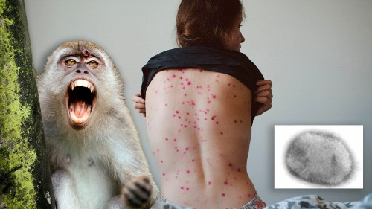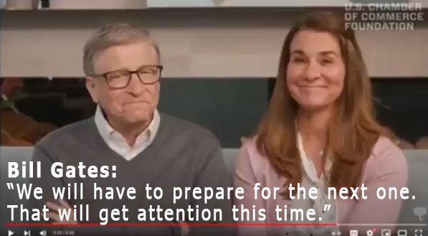**NEXT PANDEMIC, WORSE THAN THIS ONE**  
   ***“We will have to prepare for the next one. That will get attention this time.”*** Bill Gates, the owner of Moderna and shareholder in Pfizer, who [in an interview on Youtube](https://youtu.be/x6nq-JCZIHE) openly admits that his return of investment from vaccines is over 20:1 (2000% profit!) announces with the Duper’s delight grin the next pandemic. It’s amazing how the perspective of the next pandemic, even worse than the current, can make some people so happy? It’s also worth noticing the expressed certainty of knowing about the next pandemic. They also knew about the first one, when the Bill and Melinda Gates Foundation played together with the World Economic Forum the [Event 201](https://youtu.be/AoLw-Q8X174) simulation, the global pandemic exercise in October 2019 which looked so much like the COVID pandemic and just one month later the real COVID pandemic hit the world. It gives you such a strong feeling that all of it could be so well planned.   
     
   **Monkeypox** is one of the potential threats of becoming the next world wide pandemic for which once again the only solution should be expected to be provided by the same groups as with the covid vaccines. [Bill Gates warns of smallpox terror attacks and urges leaders to use ‘germ games’ to prepare](https://news.yahoo.com/bill-gates-warns-smallpox-terror-000100099.html?guccounter=1). It’s interesting to note that for the monkeypox there’s already been a simulation made by the WHO just like with covid ( [Event 201](https://youtu.be/AoLw-Q8X174)) which once again gives a quite strong impression that these events are much more likely to be planned rather than occurring by accident: [Monkey Pox Documented Simulation & Video Proof Of "Health" Agenda](https://www.bitchute.com/video/065YvPYELE8d/). Recent information shows that [Anthony Fauci’s National Institutes of Health agency was funding research to identify treatments for monkeypox shortly BEFORE the virus began spreading](https://thenationalpulse.com/2022/05/30/fauci-funded-monkeypox-virus-treatment-study/) in a global outbreak. At the same time it’s worth knowing that there might be a link between the covid vaccinations and the outbreak of smallpox and it should be investigated as well [Monkeypox: Is There A Vaccine Connection? - Dr. Vincent Carroll](https://www.bitchute.com/video/iomXdzaHL91j/) .   
     
   [BIRD FLU - the Next Pandemic](https://www.bitchute.com/video/mHuWpjRWCfga/), is a very detailed analysis video that provides a series of evidences that the bird flu that has already hit the US, Germany, UK and other countries’ poultry industries and has the potential to grow into the next pandemic among humans is coming from a virus the development of which has been funded by the Bill and Melinda Gates foundation. The foundation funded Dr. Kawaoka who took a human BP2 gene segment and spliced it to H5N1 bird flu. The result was a more lethal and even more virulent virus than the parent H5N1 strain. It’s the fraudulent PCR tests that once again are used to determine the presence of the virus and the option of compulsory vaccination of all chicken in the US is being considered (meaning all chicken eaters will take in their bodies these vaccines as well).
2. **COULD SHANGHAI’S MODEL SPREAD TO THE WEST?**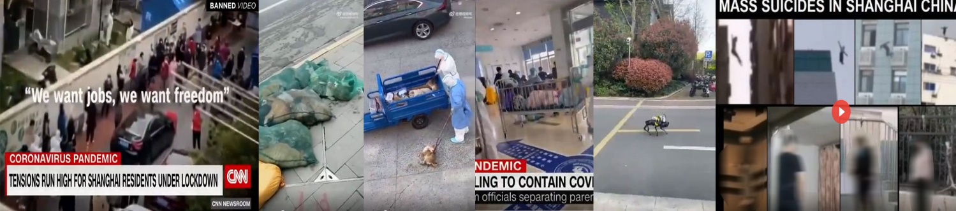  
   There have been shocking reports from China in April about the devastating health policy with zero tolerance for COVID. Keeping people for weeks in home with people screaming for help from their balconies and windows in the night, not allowing staying outside even for some sports, killing home pets of COVID positive people, separating children from their parents, robot dog with loudspeaker going alone in the streets and warning people to stay home, mass suicides – all of these are result of this policy.   
   What does this have to do with the West? The WHO and the West adopted the Chinese model for combating the first wave of COVID. What are the odds this would not happen again?
3. 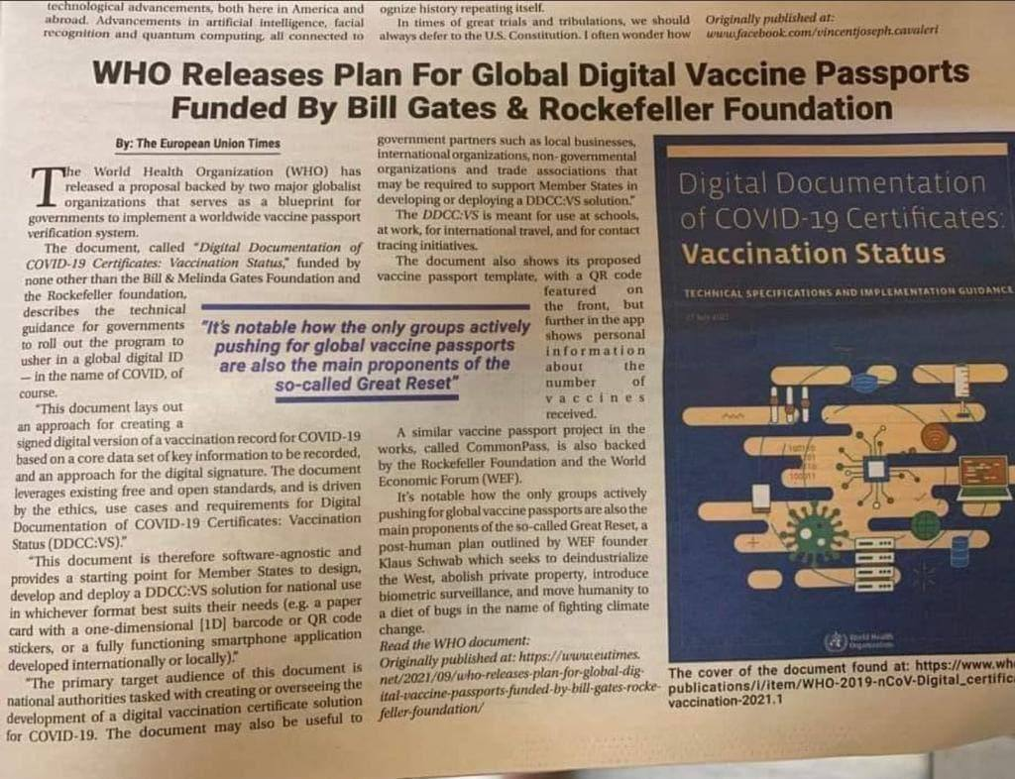**WHO IS PLANNING FOR GLOBAL DIGITAL VACCINE PASSPORTS**  
   In the face of the provided proofs in this document demonstrating that the Covid vaccines are actually instruments of electronic enslavement of the population of the world here we can translate the real meaning of the idea for global digital vaccine passports of the WHO. “We want people to be chipped, so that we can turn them into bio-robots without their own will, create new private property – transhuman organisms owned by the big pharma corporations whose interests we are actually defending.” (Bill Gates is the largest sponsor of the WHO)
4. **THE EU IS PLANNING FOR COMPULSORY VACCINATIONS AND CASHLESS SOCIETY**  
   What happens after June 30, 2022?

* The European Council has amended Resolution 2361 and no longer objects to compulsory "vaccination".
* On July 1, 2022, the EU announced legislation for mandatory EU COVID-19 certificates, which deprive people of all freedoms if they are not "vaccinated" and do not have this certificate. If the law is signed by a majority of member states, mandatory "vaccination" will be introduced.
* At the beginning of 2023 there will be a digital currency.
* The EU will introduce a digital ID card for every EU citizen. (The Dutch already have this and are already referring to the EU version at DigId.nl).
* In the near future all ATMs will be replaced by ATMs with a QR code, installation is already in full swing in Belgium.
* Soon it will no longer be possible to withdraw cash even in banks or elsewhere
* The EU aims to make cash completely useless within 1.5 years.
* The EU permanently strips everyone of their physical integrity.

**5. WHO PANDEMIC TREATY, MAY 2022**With this treaty the WHO attempted to take over the sovereignty of its members. It would have allowed to forcibly vaccinate everyone, without trial, discussion or investigation. Many countries have resisted the proposed changes, but the WHO leaders haven’t given up yet on their idea and are planning amendments for 2024.

Key points in the document:  
REFORMING THE WHO (OVERRIDING WITH EXCLUSIVE POWERS) Each Nation-State will be REQUIRED TO CONSIST WITH LAWS that impact health and go beyond the health sphere, not with national interests, but with INTERNATIONAL DUTIES TO RESPOND TO EXISTING AND "NEW" HEALTH ISSUES. A unified ideological basis is being formed to justify methods to combat the pandemic, for which, in particular, a new "science" has been declared - infodemiology, designed to combat "infodemics", by which is meant false information during epidemics, which weakens the effectiveness of global measures. The PANDEMIC AGREEMENT is a document created on the basis of the United Nations, where WHO will be given the relevant authority under this agreement. If the document in question is given life, a global, supranational and centralised structure will be established (analogous to a World Government) which will bring all countries under its influence.  
  
DISMANTLING NATION STATES:  
The PANDEMIC AGREEMENT emphasizes an expanded list of measures including: Compulsory vaccination and a broad, unrestricted exchange of data (including personal data) that would come from all countries centrally and be processed and classified in a single center under the WHO or a similar supranational globalist structure. If the PANDEMIC AGREEMENT is signed, it will effectively eliminate not only the supremacy of national law and the Constitution in each country, but also the supremacy of international law that protects human rights globally. Continuing in this context, we must be aware that such great achievements of humanity as the Nuremberg Code and the Convention on Human Rights will simply be nullified, we will be deprived of them the moment the Nation States lose their protective mechanism, i.e. humanity will find itself defenceless. Once the PANDEMIC AGREEMENT is signed, the puppet governments will delegate power into the hands of the WHO, thus the Nation-States will lose their Sovereignty. Countries will be forced under the legal weight of the above document to comply unconditionally with all orders to reduce the population, through regular and forced vaccination, and more and more restriction of rights and freedoms. Destruction of the economy and deindustrialization through endless quarantines, etc., leading to the dismantling of Nation States

1. 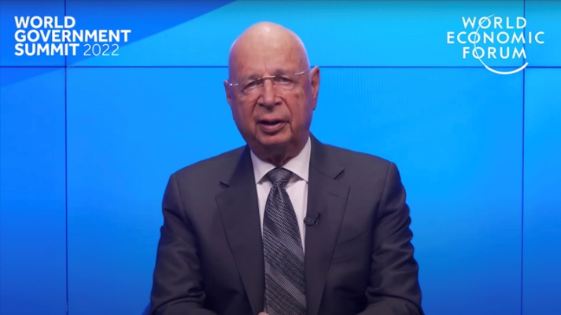**CYBER ATTACKS**  
   Klaus Schwab, the founder of the World Economic Forum warned in July 2020 about the potential of future cyber-attacks. “The COVID 19 crisis would be seen as a small disturbance in comparison to a major cyber-attack.” he warned. Since then the number of cyber-attacks has risen in the world. As a result of the cyber attack in 2021 on the Colonial Pipeline system in the USA the operations on 5,500 miles of pipeline were halted <https://zcybersecurity.com/latest-recent-cyber-attacks/> . Here we can see a list of the recent cyber-attacks around the world <https://portswigger.net/daily-swig/cyber-attacks> .
2. **FOOD SHORTAGES**The same group of people who have developed and implemented the plan for the illegal Bluetooth chipping of the population of the world has included in the package of measures for depopulation and enslavement of the nations among others also a crisis of food shortages that is supposed to crush the spirit of the people and make them accept any force-major measures for fixing of the situation where they by their own choice will to give up their sovereign rights to the New World Order in order to be able to survive. In this respect one can already observe the active measures that are already taken in this direction.

|  |  |
| --- | --- |
| [Stunning List Of 56 Food Processing Plants Destroyed Since January](https://www.bitchute.com/video/d8IR6mKgE3jL/) | [Biden Tells World to Brace for Massive Food Shortages - FULL SHOW 3/25/22](https://www.bitchute.com/video/daX3pCGYLAgw/) |
| [The UK government dropped this quietly, offering bribes to farmers to leave the profession.](https://www.gov.uk/government/publications/apply-for-a-lump-sum-payment-to-leave-or-retire-from-farming)  British agriculture only produces half the food the UK needs, instead of encouraging growth, they're doing the opposite. Why? | [Conversation with a UK Farmer about coming food shortages](https://www.bitchute.com/video/IqnUtCzgwETW/)  All the reasons why food production in UK is headed to 50% fall according to a UK farmer |

To sum it up here is what the group staying behind the illegal chipping of the population has planned for implementing in the world: **NEW WORLD ORDER UN AGENDA 21/2030 MISSION GOALS**

|  |  |
| --- | --- |
| * One World Government * One World Cashless Currency * One World Central Bank * One World Military * Mandatory multiple vaccines * Universal basic income (austerity) * Microchipped society for purchasing, travel, tracking and controlling * Implementation of a world Social Credit System (like China has) * Government owned and controlled schools, colleges and universities * The end of private transportation, owning cars, etc. * Human beings concentrated into human settlement zones and cities | * The end of national sovereignty * The end of ALL privately owned property * The end of the family unit * Depopulation, control of population growth and population density * Trillions of appliances hooked into the 5G monitoring system (Internet of things) * Government raised children * All businesses owned by government/corporations * The restriction of nonessential air travel * The end of irrigation * Restricted land use that serves human needs * The ban of natural non synthetic drugs and naturopathic medicine * The end of fossil fuels * The end of single family homes * The end of private farms and grazing livestock |

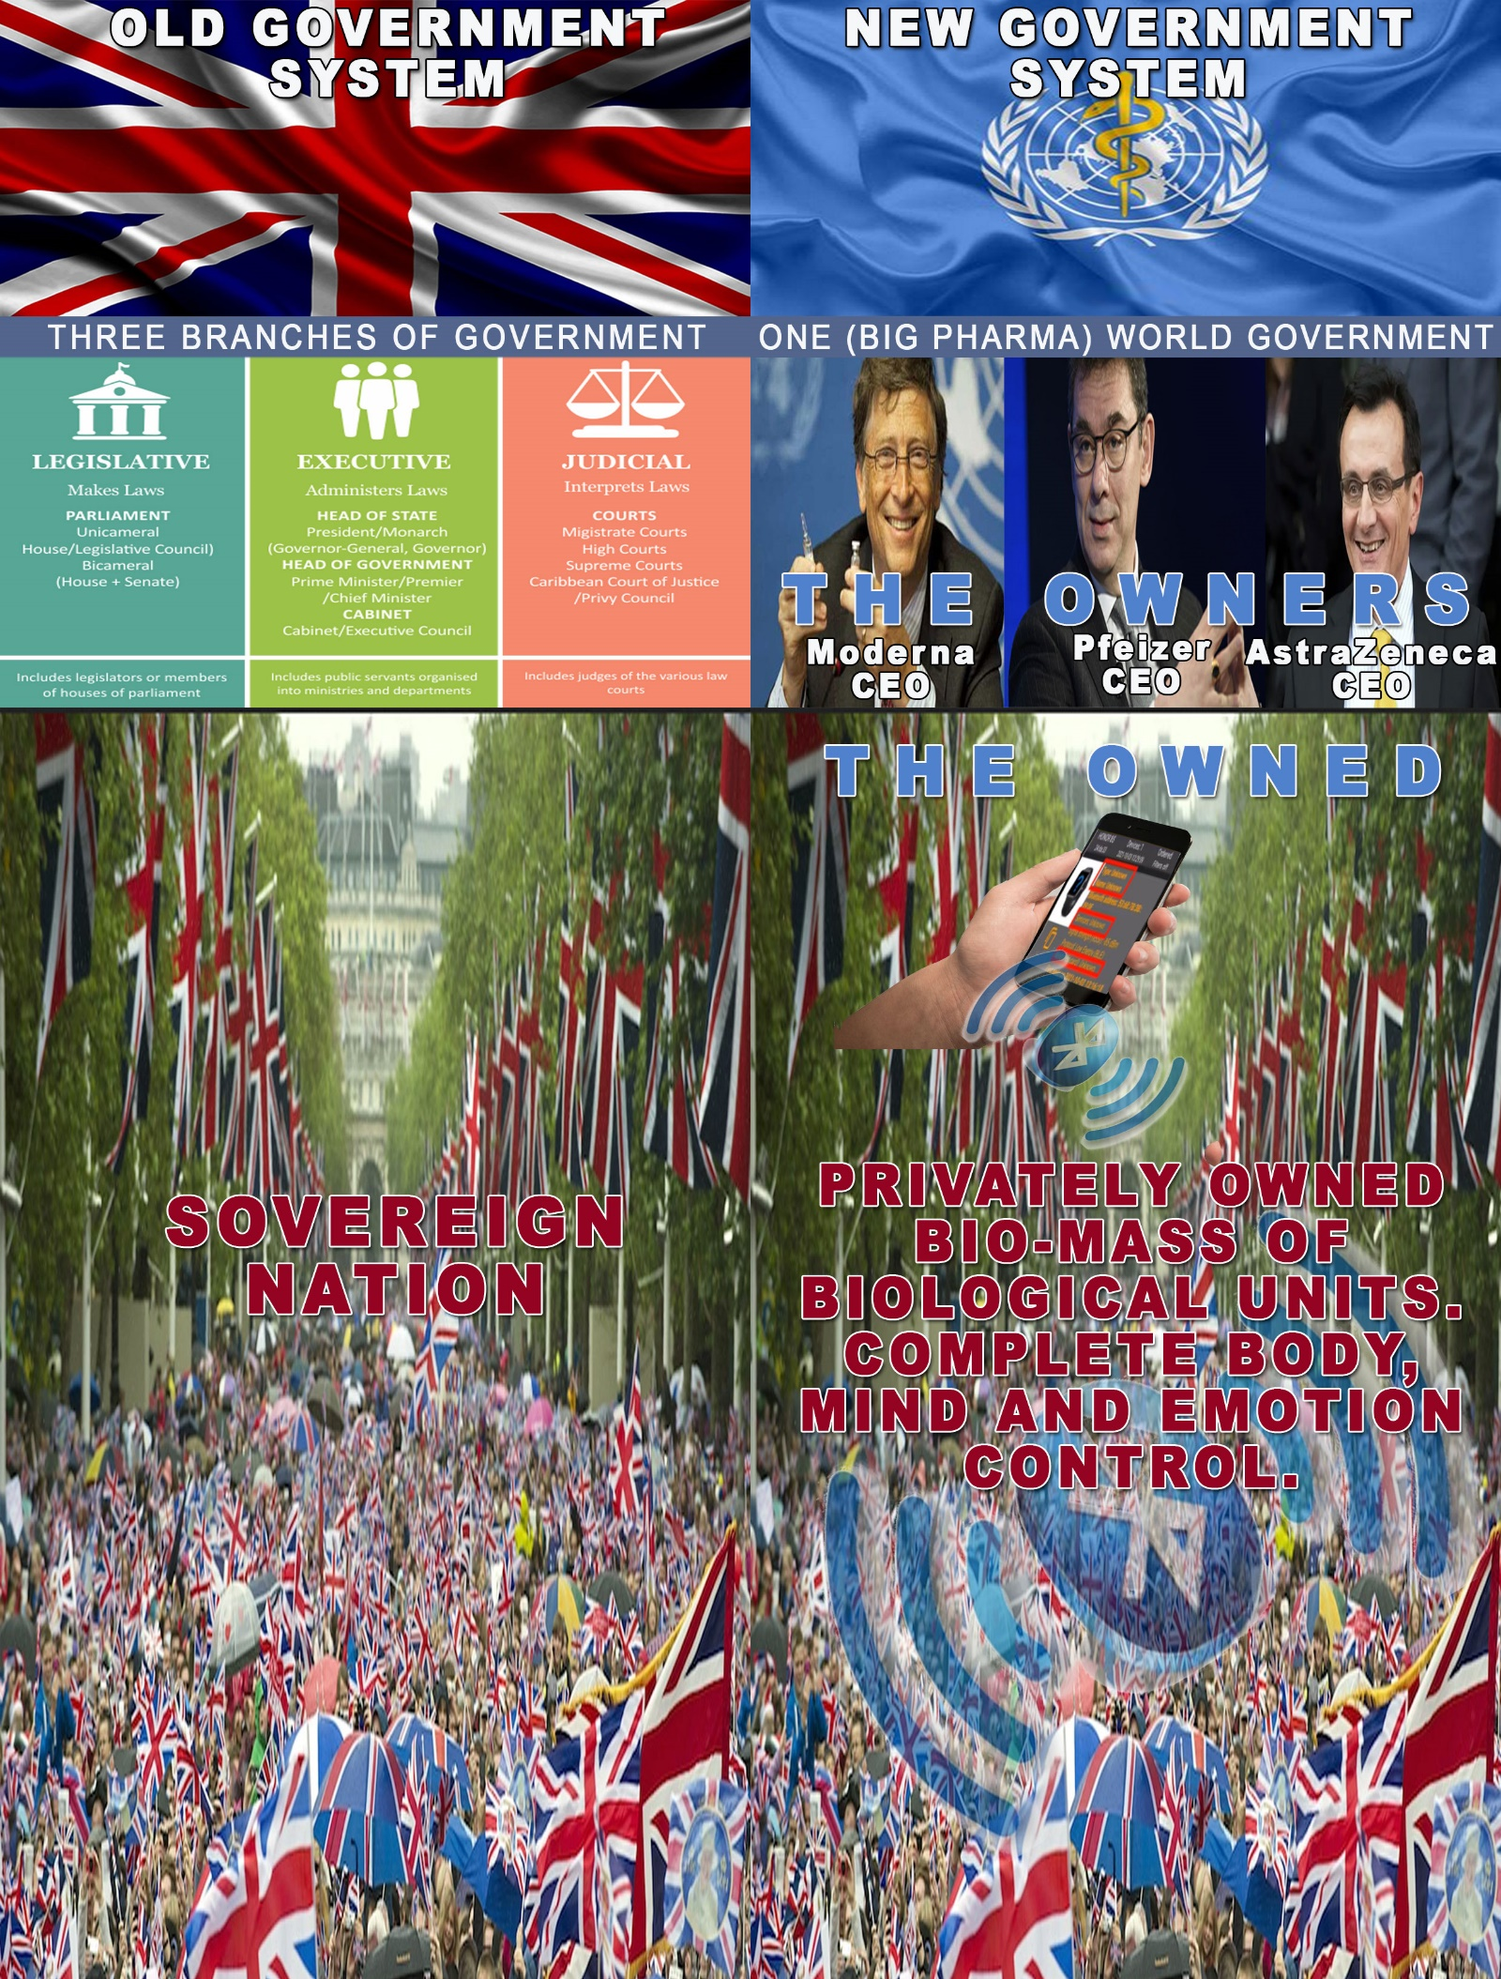Visualisation of the new government system that has already been installed by the New World Order through the support of the WHO, the government, the NHS and the mass-media and with the compliance of the masses.

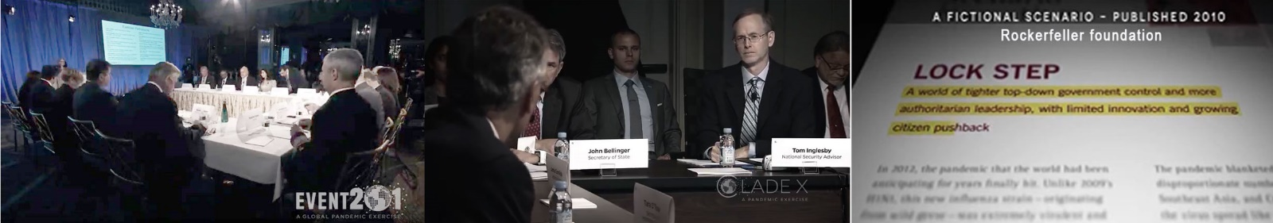**IT WAS ALL PLANNED**There’s tons of documentation and proof that everything about the covid pandemic was consciously planned for a long period of time and carefully executed in synchronicity with different organisations according to the plan. Perhaps one of the most viewed materials in this aspect is the documentary [**Plandemic** I](https://www.bitchute.com/video/TsbMDWB6R98v/) and [**Plandemic II (Indoctornation)**](https://www.bitchute.com/video/4u7rt61YeGox/).

In this documentary we see examples of numerous simulations like Event201 (done few months before the Covid19 pandemic) and Clade X (done one year before the pandemic) both organised by the Bill & Melinda Gates Foundation and the WEF and the published fictional scenario by the Rockerfeller foundation from 2010. In these simulations they describe in astonishing details the same events and developments that later happened with the Covid 19 pandemic.   
One more proof is the application for patent of a system and method for testing for COVID-19, which was filed in 2015 by the Rothschilds.

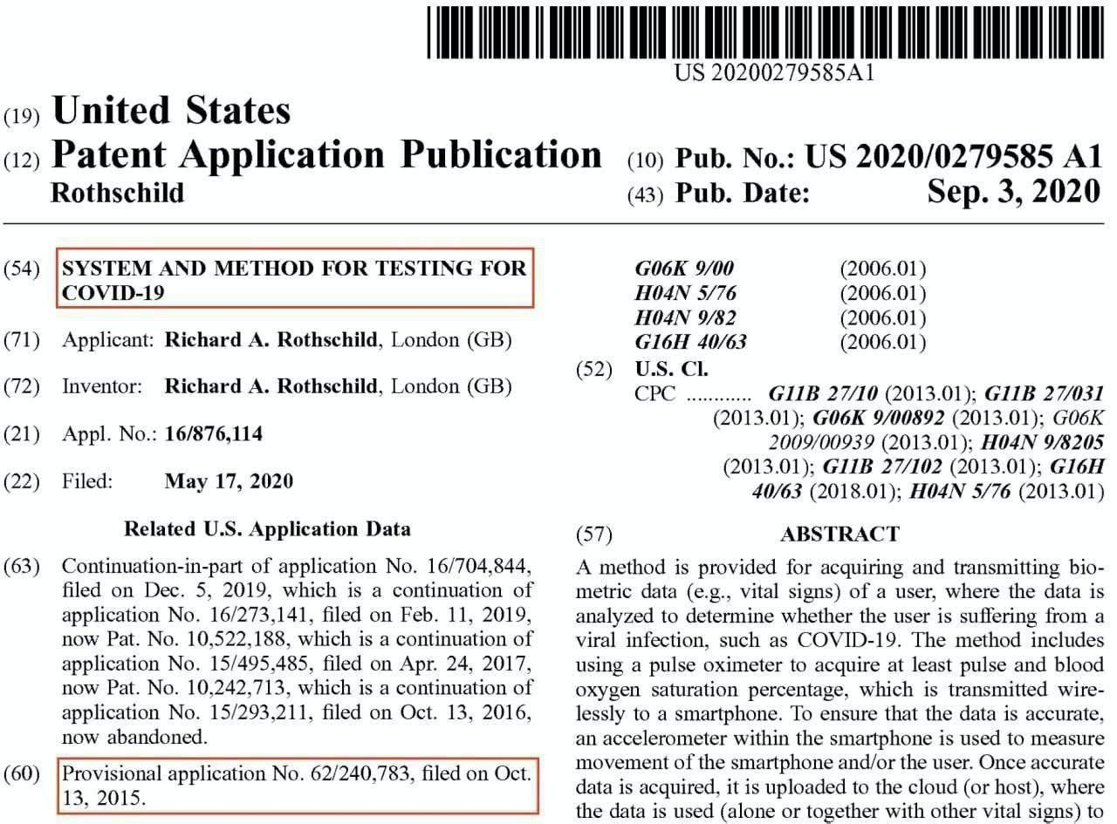

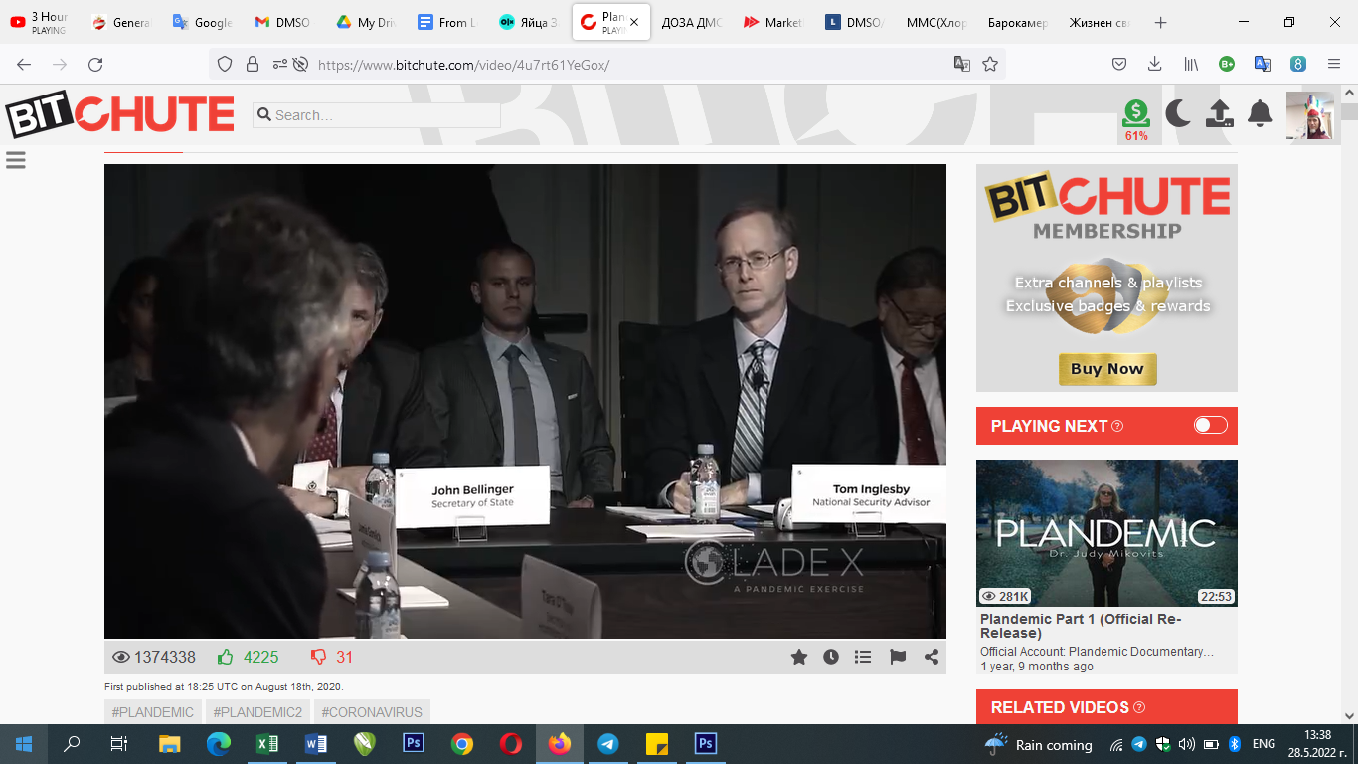

[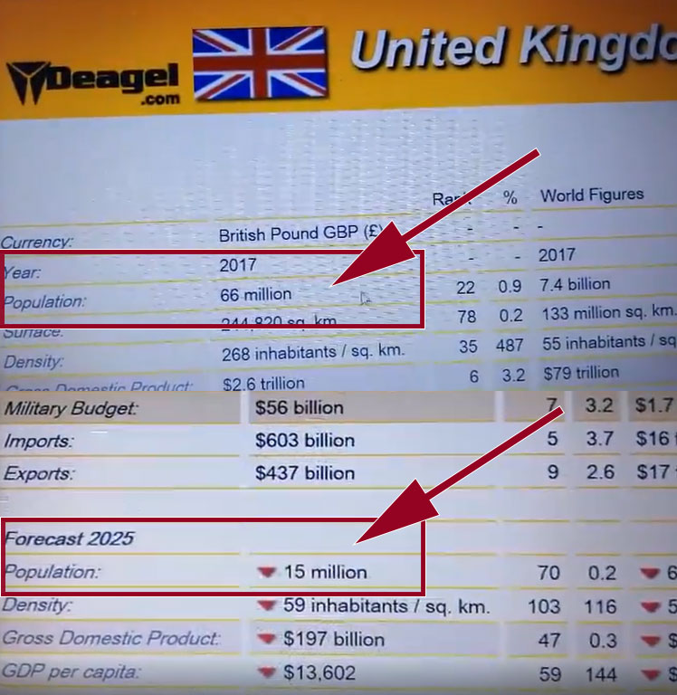](https://www.bitchute.com/video/lEBH6WiEXWPG/)A really surprising information was available on the military website Deagel.com till April 2020 about the population forecast of the world by 2025. We see that from 2017 they knew that there will be some kind of major event that will drastically reduce the populations mainly in Europe and USA. For the UK the prediction is going from 66 million in 2017 to 15 million in 2025. What are the events, trends and developments based on which such a prediction was given by this time? Now in 2022, when we have more than 50% of the UK’s population inoculated with a substance that has proven to be highly toxic and dangerous and to produce the highest amount of deaths in medical history it looks like the specialists who made this forecast knew what was coming years in advance. The other measures taken by the deep state for creating artificial food shortages and a complete economic collapse in order to force people to accept the conditions of the New World order also seems to have been taken into account. [Source](https://www.bitchute.com/video/lEBH6WiEXWPG/).